A

PROJECT REPORT

ON

**“ONLINE ART GALLERY”**

Submitted To

SHIVAJI UNIVERSITY, KOLHAPUR.

FOR THE AWARD OF

**Bachelor of Science (Computer Science**)

BY

**Miss. Aishawarya Ganu Patil**

&

**Miss. Swati Ananda Kumbhar**

Under The Guidance of

Asst. Prof. Miss. A. M. Chopade.

PRINCIPAL

**Dr. M.R. Patil**

**Dr. Ghali College, Gadhinglaj.**

**Dist. - Kolhapur**

**Year: 2022-2023**

Vidya Prasarak Mandal's

**Dr. GHALI COLLEGE, GADHINGLAJ,**

**DIST- KOLHAPUR.**

To

The Registrar,

Shivaji University,

Kolhapur.

Subject: Recommendation for B.ScIII (computer science) project.

Respected sir,

I am Dr. Patil M.R. the principal of Dr. Ghali College Gadhinglaj, recommend that the following students

Miss. Aishawarya Ganu Patil

Miss. Swati Ananda Kumbhar

Have completed the project report entitled, "Online Art Gallery" as per partial fulfillment according to the syllabus of the Shivaji University, Kolhapur under the guidance of Asst. Prof. Miss. A. M. Chopade.

Date:

Place: Gadhinglaj

The Principal

Dr. M. R. Patil

VIDYA PRASARAK MANDAL'S

**DR. GHALI COLLEGE GADHINGLAJ**

TAL-GADHINGLAJ, DIST- KOLHAPUR

Year: 2022-2023



CERTIFICATE

This is to certify that Miss. Aishawarya Ganu Patil & Miss. Swati Ananda Kumbhar successfully completed the project on the topic **"Online Art Gallery"** under my supervision and guidance, in a satisfactory manner for partial fulfillment of B.Sc.-III degree for the academic year 2022-2023.

**Date:**

**Place:** Gadhinglaj

**Guide Examiner HOD**

(Asst. Prof. Miss. A. M. Chopade) (Prof. Mrs. R.V.Hulagabali)

Vidya Prasarak Manadal's

DR.GHALI COLLEGE, GADHINGLAJ

DIST: KOLHAPUR.

**GUIDANCE CERTIFICATE**

This is to certify that the project entitled **"ONLINE ART GALLERY"** Conducted for Dr. Ghali College, Gadhinglaj by Miss .Aishawarya Ganu Patil and Miss. Swati Ananda Kumbhar. In partial fulfillment of this work for award of Bachelor of Computer Science submitted to Shivaji University, Kolhapur has been completed under my supervision and guidance.

To the best of my knowledge and brief the matter presented by them is original in nature and has not been copied from any source. Also, this report has not been submitted earlier for degree or diploma of Shivaji University, Kolhapur or any other university.

**Date:**

**Place:** Gadhinglaj

**Guide**

Asst. Prof. Miss. A. M. Chopade.

DECLARATION

We undersigned hereby declare that this report entitled **"ONLINE ART GALLERY"** is original work prepared by us under guidance of Asst. Prof. Miss. A. M. Chopade. The empirical finding in this report are based on data collected by us. The matter presented in this report is not copied from any source. We undersigned that any such copy is liable for punishment in any way the University Authorities deem to fit. This Work has not been submitted to the award of degree to Shivaji University, Kolhapur or any other University.

This work is humbly submitted to Shivaji University for the award of the degree of Bachelor of Computer Science.

**Date:**

**Place:** Gadhinglaj

Miss. Aishawarya Ganu Patil

Miss. Swati Ananda Kumbhar

**ACKNOWLAGEMENT**

For the completion of our project we look support and inspiring from a lot of people. With their valuable support and suggestions we completed this project within time successfully. We are grateful to them.

It gives us great pleasure to remain deeply indebted to our guide Asst. Prof. Miss . A. M. Chopade . Under whom we had the privilege to work. The faith and confidence shown by her in us boosted our moral and motivate to perform our better in preferring this project.

We take this opportunity to express our gratitude to the Head of Department. For providing us with the required facilities for the academic achievement.

We wish to record our sense of obligation to our parents for encouraging us to take up this course and also proceeding continuous financial assistance to us for enabling us to undergo this course and completion of the project.

Finally we are thankful for all of them who have contributed either directly or indirectly to this project.

Thanking you

Miss. Aishawarya Ganu Patil

Miss. Swati Ananda Kumbhar

INDEX

**1) Introduction to Project**

* Introduction
* Existing System
* Need and scope of System.

**2) Proposed System**

* Objectives
* SRS

**3) System Analysis**

* Methodology
* System development life cycle
* DFD
* ERD

**4) System Requirements**

* Hardware
* Software
* Front End
* Back End

**5) System Design**

* Database Design
* Output Design

**6) User Guideline**

* Installation process

**7) Source Code**

**8) Outputs**

* Input Screen & Reports (with valid Data)

**9) Testing**

**10) Conclusion and Suggestions**

* Conclusion and suggestions
* Future enhancement
* Bibliography

CHAPTER 1

**1. Introduction to Project**

* Introduction
* Existing System
* Need and scope of System.

Introduction

“Online Art Gallery” is an online website where people buy there painting from their favorite Artist. The website is contain all types of paintings. The basic need for this website is to increase the growth of the shop and spread awareness among the people about the shop so that the owner of the shop get more profit. There are many websites in which e-commerce websites which allows a customer to buy the thing online.

Here I am creating a website, which would particularly allowing the customer to buy the painting from the favorite artist. These all websites provide a payment option of cash on delivery. This project i.e. online art gallery is very helpful for customer where customer can buy directly paintings from home through internet connection where internet connection is must. This can be done through mobile phone or system.

Online art gallery is a digital platform that provides a virtual space for artists to showcase their artwork, helps art lovers to discover and buy art, and supports the art industry to thrive in the digital age.

Online art gallery typically offer a variety of art forms and styles, from paintings, kalamkari art, canvas arts, Poster color arts, folk arts and photographs to digital art. Online art gallery is secure way for buyers to purchase art without the need to travel or visit galleries person.

Existing System

Online art galleries have websites or platforms that showcase artwork from various artists. Online art galleries operate on a commission or fee based model where the gallery takes a percentage of the sale price.

In the existing system the exams are done only manually but in proposed system we have to computerize the exams using this application.

* Lack of security of data.
* More man power.
* Time consuming.
* Consumes large volume of pare work.
* Needs manual calculations.
* No direct role for the higher officials.

Need and Scope of System

My objective of making this website is to create awareness among people and different places so that the owner of the shop should get profit. It may help collecting project management details.

It will help the person to know the management of passed year perfectly, it will be also reduced the cost of collecting the management and collection procedure will go smoothly Aim is to make the website where people can view the items whenever and wherever they was anytime so there would no need to visit the shop sitting at home only people can buy the items. This would allow the customer to add or remove the items from the art through internet.

The Primary Purpose of an art gallery is to nurture visual artists, promote their work, and expose them to the public, collectors, media, and cultural institutions.

CHAPTER 2

**2. Proposed System**

* Objectives
* SRS

Objectives

The project aims and objectives at will be achieved after completion of this project are discussed in this subchapter. The aims and objectives are as follows:

* The main objective of the Online Art Gallery is to manage the details of Arts, Customer, Stock, Payment, Cash.

* It manages all the information about Arts, Bill, Cash. The project is totally built at administrative end and thus only the administrator is guaranteed the access.
* The purpose of the project is to build an application program to reduce the manual work for managing the Arts, Customer, Bill, Stock. It tracks all the details about the Stock, Payment, Cash.
* Provides the searching facilities based on various factors. Such as Arts, Cash, Bill, Stock.
* Online Art Gallery also manage the Customer details online for Bill details. Stock details, Arts.
* Shows the information and description of the Arts, Cash.
* It deals with monitoring the information and transactions of Bill.
* Editing, adding and updating of Records is improved which results in proper resource management of Arts data.

SRS

Once the existing system and analysis is done the next step is to define and document the information requirements and get them approved by the artist. This is done through SRS (Software Requirement Specification) document. SRS consists of all the information requirements to be designed and developed during the project life cycle. The outcome of this phase is Software Requirement Specification.

SRS means Understanding, Identification and critically examine the System and its part for the purpose of archiving the goals set of the system as a whole through modifications, changed interrelationship of component deleting, merging or separating the component. The methodology of system analysis involves,

1. Identification of system (setting system boundary)
2. Understanding the role and interrelationship of element of other element of system.

CHAPTER 3

**3. System Analysis**

* Methodology
* System development life cycle
* DFD
* ERD

METHODOLOGY

The methodology of developing of project will be a step-by-step sequence to design, develop and deliver the website. In software engineering this methodology called ‘waterfall model’ which one portion of work follows after another in a linear sequence. Following steps will be followed in this methodology:

* Initiation (Requirement Specification);
* Planning and design;
* Execution (construction and coding);
* Validation (Testing);
* Closure (Installation and Maintenance).

System Development Life Cycle

The process model used for this system "classic life cycle "as this is simple and is best for small scale project .

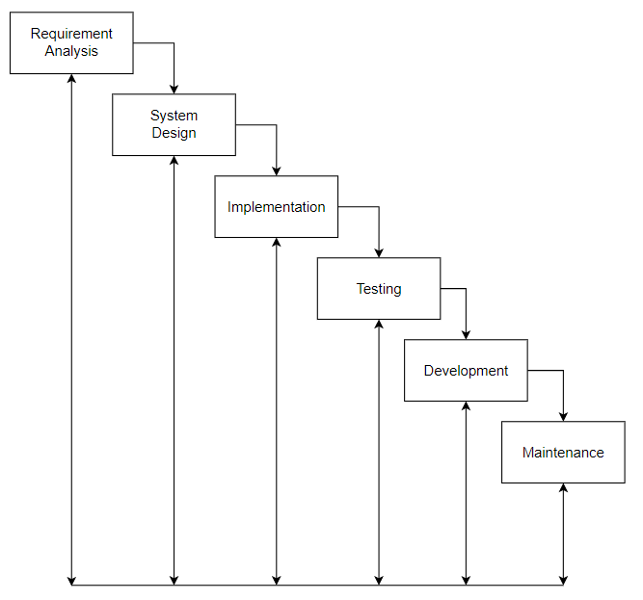

Requirement Phase:

Requirement gathering and analysis is the most important phase in software development lifecycle. Business Analyst collects the requirement from the Customer/Client as per the clients business needs and documents the requirements in the Business Requirement Organization Some examples are Customer Requirement Specification (CRS), Business Specification (BS) etc, and provides the same to Development Team.

Analysis Phase:

Once the requirement gathering and analysis is done the next step is to define and document the product requirements and get them approved by the customer This is done through SRS (Software Requirement Specification) document. SRS consists of all the product requirements to be designed and developed during the project life cycle Key people involved in this phase are Project Manager. Business Analysis and Senior members of the Team. The outcome of this phase is Software Requirement Specification.

Design Phase:

It has two steps:

HLD - High Level Design - It gives the architecture of the software product to be developed and is done by architects and senior developers

LLD - Low Level Design-It is done by senior developers. It describes how each and every feature in the product should work and how every component should work. Here, only the design will be there and not the code. The outcome from this phase is High Level Document and Low Level Document which works as an input to the next phase.

Development Phase:

Developers of all levels (senior, juniors, fresher's) involved in this phase. This is the phase where we start building the software and start writing the code for the product. The outcome from this phase is Source Code Document (SCD) and the developed product.

Testing Phase:

When the software is ready, it is send to the testing department where Test team tests it thoroughly for different defects. They either test the software manually or using automated testing tools depends on process defined in STLC (Software Testing Life Cycle) and ensure that each and every component of the QA makes sure that the software is error-free, it goes to the next stage, which is Implementation. The outcome of this phase is the Quality Product and the Testing Artifacts.

Deployment & Maintenance Phase:

After successful testing, the product is delivered/deployed to the customer for their use. Deployment is done by the Deployment/Implementation engineers. Once when the customers start using the developed system then the actual problems will come up and needs to be solved from time to time. Fixing the issues found by the customer comes in the maintenance phase. 100% testing is not possible - because, the way testers test the product is different from the way customers use the product. Maintenance should be done as per SLA (Service Level Agreement).

DFD

0th level DFD :

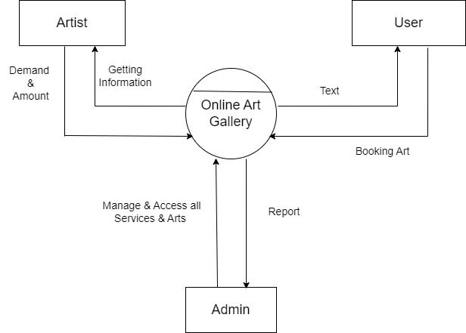

%3CmxGraphModel%3E%3Croot%3E%3CmxCell%20id%3D%220%22%2F%3E%3CmxCell%20id%3D%221%22%20parent%3D%220%22%2F%3E%3CmxCell%20id%3D%222%22%20value%3D%22Artist%22%20style%3D%22rounded%3D0%3BwhiteSpace%3Dwrap%3Bhtml%3D1%3B%22%20vertex%3D%221%22%20parent%3D%221%22%3E%3CmxGeometry%20x%3D%22140%22%20y%3D%22140%22%20width%3D%22140%22%20height%3D%2260%22%20as%3D%22geometry%22%2F%3E%3C%2FmxCell%3E%3CmxCell%20id%3D%223%22%20value%3D%22User%22%20style%3D%22rounded%3D0%3BwhiteSpace%3Dwrap%3Bhtml%3D1%3B%22%20vertex%3D%221%22%20parent%3D%221%22%3E%3CmxGeometry%20x%3D%22580%22%20y%3D%22140%22%20width%3D%22150%22%20height%3D%2260%22%20as%3D%22geometry%22%2F%3E%3C%2FmxCell%3E%3CmxCell%20id%3D%224%22%20value%3D%22Online%20Art%20Gallery%22%20style%3D%22ellipse%3BwhiteSpace%3Dwrap%3Bhtml%3D1%3Baspect%3Dfixed%3B%22%20vertex%3D%221%22%20parent%3D%221%22%3E%3CmxGeometry%20x%3D%22360%22%20y%3D%22230%22%20width%3D%22120%22%20height%3D%22120%22%20as%3D%22geometry%22%2F%3E%3C%2FmxCell%3E%3CmxCell%20id%3D%225%22%20value%3D%22%22%20style%3D%22endArrow%3Dnone%3Bhtml%3D1%3Brounded%3D0%3BentryX%3D0.95%3BentryY%3D0.263%3BentryDx%3D0%3BentryDy%3D0%3BentryPerimeter%3D0%3B%22%20edge%3D%221%22%20target%3D%224%22%20parent%3D%221%22%3E%3CmxGeometry%20width%3D%2250%22%20height%3D%2250%22%20relative%3D%221%22%20as%3D%22geometry%22%3E%3CmxPoint%20x%3D%22370%22%20y%3D%22260%22%20as%3D%22sourcePoint%22%2F%3E%3CmxPoint%20x%3D%22470%22%20y%3D%22280%22%20as%3D%22targetPoint%22%2F%3E%3CArray%20as%3D%22points%22%2F%3E%3C%2FmxGeometry%3E%3C%2FmxCell%3E%3CmxCell%20id%3D%226%22%20value%3D%22Admin%22%20style%3D%22rounded%3D0%3BwhiteSpace%3Dwrap%3Bhtml%3D1%3B%22%20vertex%3D%221%22%20parent%3D%221%22%3E%3CmxGeometry%20x%3D%22360%22%20y%3D%22520%22%20width%3D%22120%22%20height%3D%2260%22%20as%3D%22geometry%22%2F%3E%3C%2FmxCell%3E%3CmxCell%20id%3D%227%22%20value%3D%22%22%20style%3D%22endArrow%3Dclassic%3Bhtml%3D1%3Brounded%3D0%3B%22%20edge%3D%221%22%20parent%3D%221%22%3E%3CmxGeometry%20width%3D%2250%22%20height%3D%2250%22%20relative%3D%221%22%20as%3D%22geometry%22%3E%3CmxPoint%20x%3D%22640%22%20y%3D%22280%22%20as%3D%22sourcePoint%22%2F%3E%3CmxPoint%20x%3D%22640%22%20y%3D%22200%22%20as%3D%22targetPoint%22%2F%3E%3C%2FmxGeometry%3E%3C%2FmxCell%3E%3CmxCell%20id%3D%228%22%20value%3D%22%22%20style%3D%22endArrow%3Dnone%3Bhtml%3D1%3Brounded%3D0%3BexitX%3D1.017%3BexitY%3D0.417%3BexitDx%3D0%3BexitDy%3D0%3BexitPerimeter%3D0%3B%22%20edge%3D%221%22%20source%3D%224%22%20parent%3D%221%22%3E%3CmxGeometry%20width%3D%2250%22%20height%3D%2250%22%20relative%3D%221%22%20as%3D%22geometry%22%3E%3CmxPoint%20x%3D%22520%22%20y%3D%22370%22%20as%3D%22sourcePoint%22%2F%3E%3CmxPoint%20x%3D%22640%22%20y%3D%22280%22%20as%3D%22targetPoint%22%2F%3E%3C%2FmxGeometry%3E%3C%2FmxCell%3E%3CmxCell%20id%3D%229%22%20value%3D%22%22%20style%3D%22endArrow%3Dnone%3Bhtml%3D1%3Brounded%3D0%3BentryX%3D0.667%3BentryY%3D1.05%3BentryDx%3D0%3BentryDy%3D0%3BentryPerimeter%3D0%3B%22%20edge%3D%221%22%20target%3D%223%22%20parent%3D%221%22%3E%3CmxGeometry%20width%3D%2250%22%20height%3D%2250%22%20relative%3D%221%22%20as%3D%22geometry%22%3E%3CmxPoint%20x%3D%22680%22%20y%3D%22320%22%20as%3D%22sourcePoint%22%2F%3E%3CmxPoint%20x%3D%22720%22%20y%3D%22310%22%20as%3D%22targetPoint%22%2F%3E%3C%2FmxGeometry%3E%3C%2FmxCell%3E%3CmxCell%20id%3D%2210%22%20value%3D%22%22%20style%3D%22endArrow%3Dclassic%3Bhtml%3D1%3Brounded%3D0%3B%22%20edge%3D%221%22%20parent%3D%221%22%3E%3CmxGeometry%20width%3D%2250%22%20height%3D%2250%22%20relative%3D%221%22%20as%3D%22geometry%22%3E%3CmxPoint%20x%3D%22680%22%20y%3D%22320%22%20as%3D%22sourcePoint%22%2F%3E%3CmxPoint%20x%3D%22470%22%20y%3D%22320%22%20as%3D%22targetPoint%22%2F%3E%3C%2FmxGeometry%3E%3C%2FmxCell%3E%3CmxCell%20id%3D%2211%22%20value%3D%22%22%20style%3D%22endArrow%3Dclassic%3Bhtml%3D1%3Brounded%3D0%3BentryX%3D0.083%3BentryY%3D0.75%3BentryDx%3D0%3BentryDy%3D0%3BentryPerimeter%3D0%3B%22%20edge%3D%221%22%20target%3D%224%22%20parent%3D%221%22%3E%3CmxGeometry%20width%3D%2250%22%20height%3D%2250%22%20relative%3D%221%22%20as%3D%22geometry%22%3E%3CmxPoint%20x%3D%22200%22%20y%3D%22319%22%20as%3D%22sourcePoint%22%2F%3E%3CmxPoint%20x%3D%2290%22%20y%3D%22320%22%20as%3D%22targetPoint%22%2F%3E%3C%2FmxGeometry%3E%3C%2FmxCell%3E%3CmxCell%20id%3D%2212%22%20value%3D%22%22%20style%3D%22endArrow%3Dnone%3Bhtml%3D1%3Brounded%3D0%3B%22%20edge%3D%221%22%20parent%3D%221%22%3E%3CmxGeometry%20width%3D%2250%22%20height%3D%2250%22%20relative%3D%221%22%20as%3D%22geometry%22%3E%3CmxPoint%20x%3D%22200%22%20y%3D%22320%22%20as%3D%22sourcePoint%22%2F%3E%3CmxPoint%20x%3D%22200%22%20y%3D%22201%22%20as%3D%22targetPoint%22%2F%3E%3C%2FmxGeometry%3E%3C%2FmxCell%3E%3CmxCell%20id%3D%2213%22%20value%3D%22%22%20style%3D%22endArrow%3Dclassic%3Bhtml%3D1%3Brounded%3D0%3B%22%20edge%3D%221%22%20parent%3D%221%22%3E%3CmxGeometry%20width%3D%2250%22%20height%3D%2250%22%20relative%3D%221%22%20as%3D%22geometry%22%3E%3CmxPoint%20x%3D%22240%22%20y%3D%22280%22%20as%3D%22sourcePoint%22%2F%3E%3CmxPoint%20x%3D%22240%22%20y%3D%22200%22%20as%3D%22targetPoint%22%2F%3E%3C%2FmxGeometry%3E%3C%2FmxCell%3E%3CmxCell%20id%3D%2214%22%20value%3D%22%22%20style%3D%22endArrow%3Dnone%3Bhtml%3D1%3Brounded%3D0%3BentryX%3D0%3BentryY%3D0.417%3BentryDx%3D0%3BentryDy%3D0%3BentryPerimeter%3D0%3B%22%20edge%3D%221%22%20target%3D%224%22%20parent%3D%221%22%3E%3CmxGeometry%20width%3D%2250%22%20height%3D%2250%22%20relative%3D%221%22%20as%3D%22geometry%22%3E%3CmxPoint%20x%3D%22240%22%20y%3D%22280%22%20as%3D%22sourcePoint%22%2F%3E%3CmxPoint%20x%3D%22290%22%20y%3D%22230%22%20as%3D%22targetPoint%22%2F%3E%3C%2FmxGeometry%3E%3C%2FmxCell%3E%3CmxCell%20id%3D%2215%22%20value%3D%22%22%20style%3D%22endArrow%3Dclassic%3Bhtml%3D1%3Brounded%3D0%3BentryX%3D0.333%3BentryY%3D0.992%3BentryDx%3D0%3BentryDy%3D0%3BentryPerimeter%3D0%3B%22%20edge%3D%221%22%20target%3D%224%22%20parent%3D%221%22%3E%3CmxGeometry%20width%3D%2250%22%20height%3D%2250%22%20relative%3D%221%22%20as%3D%22geometry%22%3E%3CmxPoint%20x%3D%22402%22%20y%3D%22520%22%20as%3D%22sourcePoint%22%2F%3E%3CmxPoint%20x%3D%22400%22%20y%3D%22350%22%20as%3D%22targetPoint%22%2F%3E%3C%2FmxGeometry%3E%3C%2FmxCell%3E%3CmxCell%20id%3D%2216%22%20value%3D%22%22%20style%3D%22endArrow%3Dclassic%3Bhtml%3D1%3Brounded%3D0%3BentryX%3D0.667%3BentryY%3D0.033%3BentryDx%3D0%3BentryDy%3D0%3BentryPerimeter%3D0%3B%22%20edge%3D%221%22%20target%3D%226%22%20parent%3D%221%22%3E%3CmxGeometry%20width%3D%2250%22%20height%3D%2250%22%20relative%3D%221%22%20as%3D%22geometry%22%3E%3CmxPoint%20x%3D%22440%22%20y%3D%22350%22%20as%3D%22sourcePoint%22%2F%3E%3CmxPoint%20x%3D%22480%22%20y%3D%22420%22%20as%3D%22targetPoint%22%2F%3E%3C%2FmxGeometry%3E%3C%2FmxCell%3E%3CmxCell%20id%3D%2217%22%20value%3D%22Getting%20%26lt%3Bbr%26gt%3BInformation%22%20style%3D%22text%3Bhtml%3D1%3Balign%3Dcenter%3BverticalAlign%3Dmiddle%3Bresizable%3D0%3Bpoints%3D%5B%5D%3Bautosize%3D1%3BstrokeColor%3Dnone%3BfillColor%3Dnone%3B%22%20vertex%3D%221%22%20parent%3D%221%22%3E%3CmxGeometry%20x%3D%22240%22%20y%3D%22220%22%20width%3D%2280%22%20height%3D%2240%22%20as%3D%22geometry%22%2F%3E%3C%2FmxCell%3E%3CmxCell%20id%3D%2218%22%20value%3D%22Demand%26amp%3Bnbsp%3B%26lt%3Bbr%26gt%3B%26amp%3Bamp%3B%26lt%3Bbr%26gt%3BAmount%22%20style%3D%22text%3Bhtml%3D1%3Balign%3Dcenter%3BverticalAlign%3Dmiddle%3Bresizable%3D0%3Bpoints%3D%5B%5D%3Bautosize%3D1%3BstrokeColor%3Dnone%3BfillColor%3Dnone%3B%22%20vertex%3D%221%22%20parent%3D%221%22%3E%3CmxGeometry%20x%3D%22120%22%20y%3D%22220%22%20width%3D%2270%22%20height%3D%2260%22%20as%3D%22geometry%22%2F%3E%3C%2FmxCell%3E%3CmxCell%20id%3D%2219%22%20value%3D%22Manage%20%26amp%3Bamp%3B%20Access%20all%20%26lt%3Bbr%26gt%3BServices%20%26amp%3Bamp%3B%20Arts%26amp%3Bnbsp%3B%22%20style%3D%22text%3Bhtml%3D1%3Balign%3Dcenter%3BverticalAlign%3Dmiddle%3Bresizable%3D0%3Bpoints%3D%5B%5D%3Bautosize%3D1%3BstrokeColor%3Dnone%3BfillColor%3Dnone%3B%22%20vertex%3D%221%22%20parent%3D%221%22%3E%3CmxGeometry%20x%3D%22250%22%20y%3D%22400%22%20width%3D%22130%22%20height%3D%2240%22%20as%3D%22geometry%22%2F%3E%3C%2FmxCell%3E%3CmxCell%20id%3D%2220%22%20value%3D%22Report%22%20style%3D%22text%3Bhtml%3D1%3Balign%3Dcenter%3BverticalAlign%3Dmiddle%3Bresizable%3D0%3Bpoints%3D%5B%5D%3Bautosize%3D1%3BstrokeColor%3Dnone%3BfillColor%3Dnone%3B%22%20vertex%3D%221%22%20parent%3D%221%22%3E%3CmxGeometry%20x%3D%22460%22%20y%3D%22405%22%20width%3D%2260%22%20height%3D%2230%22%20as%3D%22geometry%22%2F%3E%3C%2FmxCell%3E%3CmxCell%20id%3D%2221%22%20value%3D%22Booking%20Art%22%20style%3D%22text%3Bhtml%3D1%3Balign%3Dcenter%3BverticalAlign%3Dmiddle%3Bresizable%3D0%3Bpoints%3D%5B%5D%3Bautosize%3D1%3BstrokeColor%3Dnone%3BfillColor%3Dnone%3B%22%20vertex%3D%221%22%20parent%3D%221%22%3E%3CmxGeometry%20x%3D%22580%22%20y%3D%22325%22%20width%3D%2280%22%20height%3D%2230%22%20as%3D%22geometry%22%2F%3E%3C%2FmxCell%3E%3CmxCell%20id%3D%2222%22%20value%3D%22Text%22%20style%3D%22text%3Bhtml%3D1%3Balign%3Dcenter%3BverticalAlign%3Dmiddle%3Bresizable%3D0%3Bpoints%3D%5B%5D%3Bautosize%3D1%3BstrokeColor%3Dnone%3BfillColor%3Dnone%3B%22%20vertex%3D%221%22%20parent%3D%221%22%3E%3CmxGeometry%20x%3D%22525%22%20y%3D%22245%22%20width%3D%2250%22%20height%3D%2230%22%20as%3D%22geometry%22%2F%3E%3C%2FmxCell%3E%3CmxCell%20id%3D%2223%22%20value%3D%22%26lt%3Bb%26gt%3B%26lt%3Bfont%20style%3D%26quot%3Bfont-size%3A%2014px%3B%26quot%3B%26gt%3B0%26lt%3Bsup%26gt%3Bth%26lt%3B%2Fsup%26gt%3B%20Level%20DFD%20%3A%26lt%3B%2Ffont%26gt%3B%26lt%3B%2Fb%26gt%3B%22%20style%3D%22text%3Bhtml%3D1%3Balign%3Dcenter%3BverticalAlign%3Dmiddle%3Bresizable%3D0%3Bpoints%3D%5B%5D%3Bautosize%3D1%3BstrokeColor%3Dnone%3BfillColor%3Dnone%3B%22%20vertex%3D%221%22%20parent%3D%221%22%3E%3CmxGeometry%20x%3D%2270%22%20y%3D%2250%22%20width%3D%22120%22%20height%3D%2230%22%20as%3D%22geometry%22%2F%3E%3C%2FmxCell%3E%3CmxCell%20id%3D%2224%22%20value%3D%22%26lt%3Bb%26gt%3B%26lt%3Bfont%20style%3D%26quot%3B%26quot%3B%26gt%3B%26lt%3Bspan%20style%3D%26quot%3Bfont-size%3A%2014px%3B%26quot%3B%26gt%3B1%26lt%3Bsup%26gt%3Bst%26lt%3B%2Fsup%26gt%3B%20Level%20DFD%20%3A%26lt%3B%2Fspan%26gt%3B%26lt%3B%2Ffont%26gt%3B%26lt%3B%2Fb%26gt%3B%22%20style%3D%22text%3Bhtml%3D1%3Balign%3Dcenter%3BverticalAlign%3Dmiddle%3Bresizable%3D0%3Bpoints%3D%5B%5D%3Bautosize%3D1%3BstrokeColor%3Dnone%3BfillColor%3Dnone%3B%22%20vertex%3D%221%22%20parent%3D%221%22%3E%3CmxGeometry%20x%3D%2280%22%20y%3D%22650%22%20width%3D%22120%22%20height%3D%2230%22%20as%3D%22geometry%22%2F%3E%3C%2FmxCell%3E%3CmxCell%20id%3D%2225%22%20value%3D%22Artist%22%20style%3D%22rounded%3D0%3BwhiteSpace%3Dwrap%3Bhtml%3D1%3B%22%20vertex%3D%221%22%20parent%3D%221%22%3E%3CmxGeometry%20x%3D%22110%22%20y%3D%22740%22%20width%3D%22120%22%20height%3D%2260%22%20as%3D%22geometry%22%2F%3E%3C%2FmxCell%3E%3CmxCell%20id%3D%2226%22%20value%3D%22Admin%22%20style%3D%22rounded%3D0%3BwhiteSpace%3Dwrap%3Bhtml%3D1%3B%22%20vertex%3D%221%22%20parent%3D%221%22%3E%3CmxGeometry%20x%3D%22680%22%20y%3D%22740%22%20width%3D%22120%22%20height%3D%2260%22%20as%3D%22geometry%22%2F%3E%3C%2FmxCell%3E%3CmxCell%20id%3D%2227%22%20value%3D%22Signup%22%20style%3D%22ellipse%3BwhiteSpace%3Dwrap%3Bhtml%3D1%3Baspect%3Dfixed%3B%22%20vertex%3D%221%22%20parent%3D%221%22%3E%3CmxGeometry%20x%3D%22410%22%20y%3D%22720%22%20width%3D%2290%22%20height%3D%2290%22%20as%3D%22geometry%22%2F%3E%3C%2FmxCell%3E%3CmxCell%20id%3D%2228%22%20value%3D%22%22%20style%3D%22endArrow%3Dnone%3Bhtml%3D1%3Brounded%3D0%3BentryX%3D0.963%3BentryY%3D0.338%3BentryDx%3D0%3BentryDy%3D0%3BentryPerimeter%3D0%3B%22%20edge%3D%221%22%20target%3D%2227%22%20parent%3D%221%22%3E%3CmxGeometry%20width%3D%2250%22%20height%3D%2250%22%20relative%3D%221%22%20as%3D%22geometry%22%3E%3CmxPoint%20x%3D%22410%22%20y%3D%22750%22%20as%3D%22sourcePoint%22%2F%3E%3CmxPoint%20x%3D%22460%22%20y%3D%22760%22%20as%3D%22targetPoint%22%2F%3E%3C%2FmxGeometry%3E%3C%2FmxCell%3E%3CmxCell%20id%3D%2229%22%20value%3D%221.0%22%20style%3D%22text%3Bhtml%3D1%3Balign%3Dcenter%3BverticalAlign%3Dmiddle%3Bresizable%3D0%3Bpoints%3D%5B%5D%3Bautosize%3D1%3BstrokeColor%3Dnone%3BfillColor%3Dnone%3B%22%20vertex%3D%221%22%20parent%3D%221%22%3E%3CmxGeometry%20x%3D%22430%22%20y%3D%22720%22%20width%3D%2240%22%20height%3D%2230%22%20as%3D%22geometry%22%2F%3E%3C%2FmxCell%3E%3CmxCell%20id%3D%2230%22%20value%3D%22%26lt%3Bbr%26gt%3BLogin%22%20style%3D%22ellipse%3BwhiteSpace%3Dwrap%3Bhtml%3D1%3Baspect%3Dfixed%3B%22%20vertex%3D%221%22%20parent%3D%221%22%3E%3CmxGeometry%20x%3D%22410%22%20y%3D%22880%22%20width%3D%2290%22%20height%3D%2290%22%20as%3D%22geometry%22%2F%3E%3C%2FmxCell%3E%3CmxCell%20id%3D%2231%22%20value%3D%22%22%20style%3D%22endArrow%3Dnone%3Bhtml%3D1%3Brounded%3D0%3BexitX%3D-0.012%3BexitY%3D0.375%3BexitDx%3D0%3BexitDy%3D0%3BexitPerimeter%3D0%3B%22%20edge%3D%221%22%20source%3D%2230%22%20parent%3D%221%22%3E%3CmxGeometry%20width%3D%2250%22%20height%3D%2250%22%20relative%3D%221%22%20as%3D%22geometry%22%3E%3CmxPoint%20x%3D%22420%22%20y%3D%22930%22%20as%3D%22sourcePoint%22%2F%3E%3CmxPoint%20x%3D%22500%22%20y%3D%22914%22%20as%3D%22targetPoint%22%2F%3E%3C%2FmxGeometry%3E%3C%2FmxCell%3E%3CmxCell%20id%3D%2232%22%20value%3D%222.0%22%20style%3D%22text%3Bhtml%3D1%3Balign%3Dcenter%3BverticalAlign%3Dmiddle%3Bresizable%3D0%3Bpoints%3D%5B%5D%3Bautosize%3D1%3BstrokeColor%3Dnone%3BfillColor%3Dnone%3B%22%20vertex%3D%221%22%20parent%3D%221%22%3E%3CmxGeometry%20x%3D%22430%22%20y%3D%22880%22%20width%3D%2240%22%20height%3D%2230%22%20as%3D%22geometry%22%2F%3E%3C%2FmxCell%3E%3CmxCell%20id%3D%2233%22%20value%3D%22%26lt%3Bbr%26gt%3BLog%20out%22%20style%3D%22ellipse%3BwhiteSpace%3Dwrap%3Bhtml%3D1%3Baspect%3Dfixed%3B%22%20vertex%3D%221%22%20parent%3D%221%22%3E%3CmxGeometry%20x%3D%22410%22%20y%3D%221190%22%20width%3D%2290%22%20height%3D%2290%22%20as%3D%22geometry%22%2F%3E%3C%2FmxCell%3E%3CmxCell%20id%3D%2234%22%20value%3D%22%26lt%3Bbr%26gt%3B%26lt%3Bbr%26gt%3BManage%20%26amp%3Bamp%3B%20access%20all%20Services%22%20style%3D%22ellipse%3BwhiteSpace%3Dwrap%3Bhtml%3D1%3Baspect%3Dfixed%3B%22%20vertex%3D%221%22%20parent%3D%221%22%3E%3CmxGeometry%20x%3D%22410%22%20y%3D%221030%22%20width%3D%2290%22%20height%3D%2290%22%20as%3D%22geometry%22%2F%3E%3C%2FmxCell%3E%3CmxCell%20id%3D%2235%22%20value%3D%22%22%20style%3D%22endArrow%3Dnone%3Bhtml%3D1%3Brounded%3D0%3BexitX%3D0.038%3BexitY%3D0.363%3BexitDx%3D0%3BexitDy%3D0%3BexitPerimeter%3D0%3B%22%20edge%3D%221%22%20source%3D%2234%22%20parent%3D%221%22%3E%3CmxGeometry%20width%3D%2250%22%20height%3D%2250%22%20relative%3D%221%22%20as%3D%22geometry%22%3E%3CmxPoint%20x%3D%22400%22%20y%3D%221150%22%20as%3D%22sourcePoint%22%2F%3E%3CmxPoint%20x%3D%22500%22%20y%3D%221063%22%20as%3D%22targetPoint%22%2F%3E%3C%2FmxGeometry%3E%3C%2FmxCell%3E%3CmxCell%20id%3D%2236%22%20value%3D%22%22%20style%3D%22endArrow%3Dnone%3Bhtml%3D1%3Brounded%3D0%3BentryX%3D1%3BentryY%3D0.375%3BentryDx%3D0%3BentryDy%3D0%3BentryPerimeter%3D0%3B%22%20edge%3D%221%22%20target%3D%2233%22%20parent%3D%221%22%3E%3CmxGeometry%20width%3D%2250%22%20height%3D%2250%22%20relative%3D%221%22%20as%3D%22geometry%22%3E%3CmxPoint%20x%3D%22410%22%20y%3D%221224%22%20as%3D%22sourcePoint%22%2F%3E%3CmxPoint%20x%3D%22460%22%20y%3D%221170%22%20as%3D%22targetPoint%22%2F%3E%3C%2FmxGeometry%3E%3C%2FmxCell%3E%3CmxCell%20id%3D%2237%22%20value%3D%223.0%22%20style%3D%22text%3Bhtml%3D1%3Balign%3Dcenter%3BverticalAlign%3Dmiddle%3Bresizable%3D0%3Bpoints%3D%5B%5D%3Bautosize%3D1%3BstrokeColor%3Dnone%3BfillColor%3Dnone%3B%22%20vertex%3D%221%22%20parent%3D%221%22%3E%3CmxGeometry%20x%3D%22435%22%20y%3D%221030%22%20width%3D%2240%22%20height%3D%2230%22%20as%3D%22geometry%22%2F%3E%3C%2FmxCell%3E%3CmxCell%20id%3D%2238%22%20value%3D%224.0%22%20style%3D%22text%3Bhtml%3D1%3Balign%3Dcenter%3BverticalAlign%3Dmiddle%3Bresizable%3D0%3Bpoints%3D%5B%5D%3Bautosize%3D1%3BstrokeColor%3Dnone%3BfillColor%3Dnone%3B%22%20vertex%3D%221%22%20parent%3D%221%22%3E%3CmxGeometry%20x%3D%22435%22%20y%3D%221190%22%20width%3D%2240%22%20height%3D%2230%22%20as%3D%22geometry%22%2F%3E%3C%2FmxCell%3E%3CmxCell%20id%3D%2239%22%20value%3D%22%22%20style%3D%22endArrow%3Dclassic%3Bhtml%3D1%3Brounded%3D0%3B%22%20edge%3D%221%22%20parent%3D%221%22%3E%3CmxGeometry%20width%3D%2250%22%20height%3D%2250%22%20relative%3D%221%22%20as%3D%22geometry%22%3E%3CmxPoint%20x%3D%22230%22%20y%3D%22760%22%20as%3D%22sourcePoint%22%2F%3E%3CmxPoint%20x%3D%22410%22%20y%3D%22760%22%20as%3D%22targetPoint%22%2F%3E%3C%2FmxGeometry%3E%3C%2FmxCell%3E%3CmxCell%20id%3D%2240%22%20value%3D%22%22%20style%3D%22endArrow%3Dclassic%3Bhtml%3D1%3Brounded%3D0%3B%22%20edge%3D%221%22%20parent%3D%221%22%3E%3CmxGeometry%20width%3D%2250%22%20height%3D%2250%22%20relative%3D%221%22%20as%3D%22geometry%22%3E%3CmxPoint%20x%3D%22500%22%20y%3D%22760%22%20as%3D%22sourcePoint%22%2F%3E%3CmxPoint%20x%3D%22680%22%20y%3D%22760%22%20as%3D%22targetPoint%22%2F%3E%3C%2FmxGeometry%3E%3C%2FmxCell%3E%3CmxCell%20id%3D%2241%22%20value%3D%22%22%20style%3D%22endArrow%3Dclassic%3Bhtml%3D1%3Brounded%3D0%3BexitX%3D-0.011%3BexitY%3D0.633%3BexitDx%3D0%3BexitDy%3D0%3BexitPerimeter%3D0%3B%22%20edge%3D%221%22%20source%3D%2227%22%20parent%3D%221%22%3E%3CmxGeometry%20width%3D%2250%22%20height%3D%2250%22%20relative%3D%221%22%20as%3D%22geometry%22%3E%3CmxPoint%20x%3D%22320%22%20y%3D%22820%22%20as%3D%22sourcePoint%22%2F%3E%3CmxPoint%20x%3D%22230%22%20y%3D%22777%22%20as%3D%22targetPoint%22%2F%3E%3C%2FmxGeometry%3E%3C%2FmxCell%3E%3CmxCell%20id%3D%2242%22%20value%3D%22%22%20style%3D%22endArrow%3Dclassic%3Bhtml%3D1%3Brounded%3D0%3BexitX%3D-0.017%3BexitY%3D0.65%3BexitDx%3D0%3BexitDy%3D0%3BexitPerimeter%3D0%3B%22%20edge%3D%221%22%20source%3D%2226%22%20parent%3D%221%22%3E%3CmxGeometry%20width%3D%2250%22%20height%3D%2250%22%20relative%3D%221%22%20as%3D%22geometry%22%3E%3CmxPoint%20x%3D%22580%22%20y%3D%22820%22%20as%3D%22sourcePoint%22%2F%3E%3CmxPoint%20x%3D%22500%22%20y%3D%22780%22%20as%3D%22targetPoint%22%2F%3E%3C%2FmxGeometry%3E%3C%2FmxCell%3E%3CmxCell%20id%3D%2243%22%20value%3D%22%22%20style%3D%22endArrow%3Dclassic%3Bhtml%3D1%3Brounded%3D0%3BexitX%3D0.5%3BexitY%3D1%3BexitDx%3D0%3BexitDy%3D0%3B%22%20edge%3D%221%22%20source%3D%2227%22%20parent%3D%221%22%3E%3CmxGeometry%20width%3D%2250%22%20height%3D%2250%22%20relative%3D%221%22%20as%3D%22geometry%22%3E%3CmxPoint%20x%3D%22430%22%20y%3D%22870%22%20as%3D%22sourcePoint%22%2F%3E%3CmxPoint%20x%3D%22455%22%20y%3D%22880%22%20as%3D%22targetPoint%22%2F%3E%3C%2FmxGeometry%3E%3C%2FmxCell%3E%3CmxCell%20id%3D%2244%22%20value%3D%22%22%20style%3D%22endArrow%3Dclassic%3Bhtml%3D1%3Brounded%3D0%3BentryX%3D0.525%3BentryY%3D-0.033%3BentryDx%3D0%3BentryDy%3D0%3BentryPerimeter%3D0%3BexitX%3D0.5%3BexitY%3D1%3BexitDx%3D0%3BexitDy%3D0%3B%22%20edge%3D%221%22%20source%3D%2230%22%20target%3D%2237%22%20parent%3D%221%22%3E%3CmxGeometry%20width%3D%2250%22%20height%3D%2250%22%20relative%3D%221%22%20as%3D%22geometry%22%3E%3CmxPoint%20x%3D%22400%22%20y%3D%22980%22%20as%3D%22sourcePoint%22%2F%3E%3CmxPoint%20x%3D%22450%22%20y%3D%22930%22%20as%3D%22targetPoint%22%2F%3E%3C%2FmxGeometry%3E%3C%2FmxCell%3E%3CmxCell%20id%3D%2245%22%20value%3D%22%22%20style%3D%22endArrow%3Dclassic%3Bhtml%3D1%3Brounded%3D0%3BentryX%3D0.5%3BentryY%3D-0.067%3BentryDx%3D0%3BentryDy%3D0%3BentryPerimeter%3D0%3BexitX%3D0.5%3BexitY%3D1%3BexitDx%3D0%3BexitDy%3D0%3B%22%20edge%3D%221%22%20source%3D%2234%22%20target%3D%2238%22%20parent%3D%221%22%3E%3CmxGeometry%20width%3D%2250%22%20height%3D%2250%22%20relative%3D%221%22%20as%3D%22geometry%22%3E%3CmxPoint%20x%3D%22400%22%20y%3D%221130%22%20as%3D%22sourcePoint%22%2F%3E%3CmxPoint%20x%3D%22460%22%20y%3D%221170%22%20as%3D%22targetPoint%22%2F%3E%3C%2FmxGeometry%3E%3C%2FmxCell%3E%3C%2Froot%3E%3C%2FmxGraphModel%3E%3CmxGraphModel%3E%3Croot%3E%3CmxCell%20id%3D%220%22%2F%3E%3CmxCell%20id%3D%221%22%20parent%3D%220%22%2F%3E%3CmxCell%20id%3D%222%22%20value%3D%22Artist%22%20style%3D%22rounded%3D0%3BwhiteSpace%3Dwrap%3Bhtml%3D1%3B%22%20vertex%3D%221%22%20parent%3D%221%22%3E%3CmxGeometry%20x%3D%22140%22%20y%3D%22140%22%20width%3D%22140%22%20height%3D%2260%22%20as%3D%22geometry%22%2F%3E%3C%2FmxCell%3E%3CmxCell%20id%3D%223%22%20value%3D%22User%22%20style%3D%22rounded%3D0%3BwhiteSpace%3Dwrap%3Bhtml%3D1%3B%22%20vertex%3D%221%22%20parent%3D%221%22%3E%3CmxGeometry%20x%3D%22580%22%20y%3D%22140%22%20width%3D%22150%22%20height%3D%2260%22%20as%3D%22geometry%22%2F%3E%3C%2FmxCell%3E%3CmxCell%20id%3D%224%22%20value%3D%22Online%20Art%20Gallery%22%20style%3D%22ellipse%3BwhiteSpace%3Dwrap%3Bhtml%3D1%3Baspect%3Dfixed%3B%22%20vertex%3D%221%22%20parent%3D%221%22%3E%3CmxGeometry%20x%3D%22360%22%20y%3D%22230%22%20width%3D%22120%22%20height%3D%22120%22%20as%3D%22geometry%22%2F%3E%3C%2FmxCell%3E%3CmxCell%20id%3D%225%22%20value%3D%22%22%20style%3D%22endArrow%3Dnone%3Bhtml%3D1%3Brounded%3D0%3BentryX%3D0.95%3BentryY%3D0.263%3BentryDx%3D0%3BentryDy%3D0%3BentryPerimeter%3D0%3B%22%20edge%3D%221%22%20target%3D%224%22%20parent%3D%221%22%3E%3CmxGeometry%20width%3D%2250%22%20height%3D%2250%22%20relative%3D%221%22%20as%3D%22geometry%22%3E%3CmxPoint%20x%3D%22370%22%20y%3D%22260%22%20as%3D%22sourcePoint%22%2F%3E%3CmxPoint%20x%3D%22470%22%20y%3D%22280%22%20as%3D%22targetPoint%22%2F%3E%3CArray%20as%3D%22points%22%2F%3E%3C%2FmxGeometry%3E%3C%2FmxCell%3E%3CmxCell%20id%3D%226%22%20value%3D%22Admin%22%20style%3D%22rounded%3D0%3BwhiteSpace%3Dwrap%3Bhtml%3D1%3B%22%20vertex%3D%221%22%20parent%3D%221%22%3E%3CmxGeometry%20x%3D%22360%22%20y%3D%22520%22%20width%3D%22120%22%20height%3D%2260%22%20as%3D%22geometry%22%2F%3E%3C%2FmxCell%3E%3CmxCell%20id%3D%227%22%20value%3D%22%22%20style%3D%22endArrow%3Dclassic%3Bhtml%3D1%3Brounded%3D0%3B%22%20edge%3D%221%22%20parent%3D%221%22%3E%3CmxGeometry%20width%3D%2250%22%20height%3D%2250%22%20relative%3D%221%22%20as%3D%22geometry%22%3E%3CmxPoint%20x%3D%22640%22%20y%3D%22280%22%20as%3D%22sourcePoint%22%2F%3E%3CmxPoint%20x%3D%22640%22%20y%3D%22200%22%20as%3D%22targetPoint%22%2F%3E%3C%2FmxGeometry%3E%3C%2FmxCell%3E%3CmxCell%20id%3D%228%22%20value%3D%22%22%20style%3D%22endArrow%3Dnone%3Bhtml%3D1%3Brounded%3D0%3BexitX%3D1.017%3BexitY%3D0.417%3BexitDx%3D0%3BexitDy%3D0%3BexitPerimeter%3D0%3B%22%20edge%3D%221%22%20source%3D%224%22%20parent%3D%221%22%3E%3CmxGeometry%20width%3D%2250%22%20height%3D%2250%22%20relative%3D%221%22%20as%3D%22geometry%22%3E%3CmxPoint%20x%3D%22520%22%20y%3D%22370%22%20as%3D%22sourcePoint%22%2F%3E%3CmxPoint%20x%3D%22640%22%20y%3D%22280%22%20as%3D%22targetPoint%22%2F%3E%3C%2FmxGeometry%3E%3C%2FmxCell%3E%3CmxCell%20id%3D%229%22%20value%3D%22%22%20style%3D%22endArrow%3Dnone%3Bhtml%3D1%3Brounded%3D0%3BentryX%3D0.667%3BentryY%3D1.05%3BentryDx%3D0%3BentryDy%3D0%3BentryPerimeter%3D0%3B%22%20edge%3D%221%22%20target%3D%223%22%20parent%3D%221%22%3E%3CmxGeometry%20width%3D%2250%22%20height%3D%2250%22%20relative%3D%221%22%20as%3D%22geometry%22%3E%3CmxPoint%20x%3D%22680%22%20y%3D%22320%22%20as%3D%22sourcePoint%22%2F%3E%3CmxPoint%20x%3D%22720%22%20y%3D%22310%22%20as%3D%22targetPoint%22%2F%3E%3C%2FmxGeometry%3E%3C%2FmxCell%3E%3CmxCell%20id%3D%2210%22%20value%3D%22%22%20style%3D%22endArrow%3Dclassic%3Bhtml%3D1%3Brounded%3D0%3B%22%20edge%3D%221%22%20parent%3D%221%22%3E%3CmxGeometry%20width%3D%2250%22%20height%3D%2250%22%20relative%3D%221%22%20as%3D%22geometry%22%3E%3CmxPoint%20x%3D%22680%22%20y%3D%22320%22%20as%3D%22sourcePoint%22%2F%3E%3CmxPoint%20x%3D%22470%22%20y%3D%22320%22%20as%3D%22targetPoint%22%2F%3E%3C%2FmxGeometry%3E%3C%2FmxCell%3E%3CmxCell%20id%3D%2211%22%20value%3D%22%22%20style%3D%22endArrow%3Dclassic%3Bhtml%3D1%3Brounded%3D0%3BentryX%3D0.083%3BentryY%3D0.75%3BentryDx%3D0%3BentryDy%3D0%3BentryPerimeter%3D0%3B%22%20edge%3D%221%22%20target%3D%224%22%20parent%3D%221%22%3E%3CmxGeometry%20width%3D%2250%22%20height%3D%2250%22%20relative%3D%221%22%20as%3D%22geometry%22%3E%3CmxPoint%20x%3D%22200%22%20y%3D%22319%22%20as%3D%22sourcePoint%22%2F%3E%3CmxPoint%20x%3D%2290%22%20y%3D%22320%22%20as%3D%22targetPoint%22%2F%3E%3C%2FmxGeometry%3E%3C%2FmxCell%3E%3CmxCell%20id%3D%2212%22%20value%3D%22%22%20style%3D%22endArrow%3Dnone%3Bhtml%3D1%3Brounded%3D0%3B%22%20edge%3D%221%22%20parent%3D%221%22%3E%3CmxGeometry%20width%3D%2250%22%20height%3D%2250%22%20relative%3D%221%22%20as%3D%22geometry%22%3E%3CmxPoint%20x%3D%22200%22%20y%3D%22320%22%20as%3D%22sourcePoint%22%2F%3E%3CmxPoint%20x%3D%22200%22%20y%3D%22201%22%20as%3D%22targetPoint%22%2F%3E%3C%2FmxGeometry%3E%3C%2FmxCell%3E%3CmxCell%20id%3D%2213%22%20value%3D%22%22%20style%3D%22endArrow%3Dclassic%3Bhtml%3D1%3Brounded%3D0%3B%22%20edge%3D%221%22%20parent%3D%221%22%3E%3CmxGeometry%20width%3D%2250%22%20height%3D%2250%22%20relative%3D%221%22%20as%3D%22geometry%22%3E%3CmxPoint%20x%3D%22240%22%20y%3D%22280%22%20as%3D%22sourcePoint%22%2F%3E%3CmxPoint%20x%3D%22240%22%20y%3D%22200%22%20as%3D%22targetPoint%22%2F%3E%3C%2FmxGeometry%3E%3C%2FmxCell%3E%3CmxCell%20id%3D%2214%22%20value%3D%22%22%20style%3D%22endArrow%3Dnone%3Bhtml%3D1%3Brounded%3D0%3BentryX%3D0%3BentryY%3D0.417%3BentryDx%3D0%3BentryDy%3D0%3BentryPerimeter%3D0%3B%22%20edge%3D%221%22%20target%3D%224%22%20parent%3D%221%22%3E%3CmxGeometry%20width%3D%2250%22%20height%3D%2250%22%20relative%3D%221%22%20as%3D%22geometry%22%3E%3CmxPoint%20x%3D%22240%22%20y%3D%22280%22%20as%3D%22sourcePoint%22%2F%3E%3CmxPoint%20x%3D%22290%22%20y%3D%22230%22%20as%3D%22targetPoint%22%2F%3E%3C%2FmxGeometry%3E%3C%2FmxCell%3E%3CmxCell%20id%3D%2215%22%20value%3D%22%22%20style%3D%22endArrow%3Dclassic%3Bhtml%3D1%3Brounded%3D0%3BentryX%3D0.333%3BentryY%3D0.992%3BentryDx%3D0%3BentryDy%3D0%3BentryPerimeter%3D0%3B%22%20edge%3D%221%22%20target%3D%224%22%20parent%3D%221%22%3E%3CmxGeometry%20width%3D%2250%22%20height%3D%2250%22%20relative%3D%221%22%20as%3D%22geometry%22%3E%3CmxPoint%20x%3D%22402%22%20y%3D%22520%22%20as%3D%22sourcePoint%22%2F%3E%3CmxPoint%20x%3D%22400%22%20y%3D%22350%22%20as%3D%22targetPoint%22%2F%3E%3C%2FmxGeometry%3E%3C%2FmxCell%3E%3CmxCell%20id%3D%2216%22%20value%3D%22%22%20style%3D%22endArrow%3Dclassic%3Bhtml%3D1%3Brounded%3D0%3BentryX%3D0.667%3BentryY%3D0.033%3BentryDx%3D0%3BentryDy%3D0%3BentryPerimeter%3D0%3B%22%20edge%3D%221%22%20target%3D%226%22%20parent%3D%221%22%3E%3CmxGeometry%20width%3D%2250%22%20height%3D%2250%22%20relative%3D%221%22%20as%3D%22geometry%22%3E%3CmxPoint%20x%3D%22440%22%20y%3D%22350%22%20as%3D%22sourcePoint%22%2F%3E%3CmxPoint%20x%3D%22480%22%20y%3D%22420%22%20as%3D%22targetPoint%22%2F%3E%3C%2FmxGeometry%3E%3C%2FmxCell%3E%3CmxCell%20id%3D%2217%22%20value%3D%22Getting%20%26lt%3Bbr%26gt%3BInformation%22%20style%3D%22text%3Bhtml%3D1%3Balign%3Dcenter%3BverticalAlign%3Dmiddle%3Bresizable%3D0%3Bpoints%3D%5B%5D%3Bautosize%3D1%3BstrokeColor%3Dnone%3BfillColor%3Dnone%3B%22%20vertex%3D%221%22%20parent%3D%221%22%3E%3CmxGeometry%20x%3D%22240%22%20y%3D%22220%22%20width%3D%2280%22%20height%3D%2240%22%20as%3D%22geometry%22%2F%3E%3C%2FmxCell%3E%3CmxCell%20id%3D%2218%22%20value%3D%22Demand%26amp%3Bnbsp%3B%26lt%3Bbr%26gt%3B%26amp%3Bamp%3B%26lt%3Bbr%26gt%3BAmount%22%20style%3D%22text%3Bhtml%3D1%3Balign%3Dcenter%3BverticalAlign%3Dmiddle%3Bresizable%3D0%3Bpoints%3D%5B%5D%3Bautosize%3D1%3BstrokeColor%3Dnone%3BfillColor%3Dnone%3B%22%20vertex%3D%221%22%20parent%3D%221%22%3E%3CmxGeometry%20x%3D%22120%22%20y%3D%22220%22%20width%3D%2270%22%20height%3D%2260%22%20as%3D%22geometry%22%2F%3E%3C%2FmxCell%3E%3CmxCell%20id%3D%2219%22%20value%3D%22Manage%20%26amp%3Bamp%3B%20Access%20all%20%26lt%3Bbr%26gt%3BServices%20%26amp%3Bamp%3B%20Arts%26amp%3Bnbsp%3B%22%20style%3D%22text%3Bhtml%3D1%3Balign%3Dcenter%3BverticalAlign%3Dmiddle%3Bresizable%3D0%3Bpoints%3D%5B%5D%3Bautosize%3D1%3BstrokeColor%3Dnone%3BfillColor%3Dnone%3B%22%20vertex%3D%221%22%20parent%3D%221%22%3E%3CmxGeometry%20x%3D%22250%22%20y%3D%22400%22%20width%3D%22130%22%20height%3D%2240%22%20as%3D%22geometry%22%2F%3E%3C%2FmxCell%3E%3CmxCell%20id%3D%2220%22%20value%3D%22Report%22%20style%3D%22text%3Bhtml%3D1%3Balign%3Dcenter%3BverticalAlign%3Dmiddle%3Bresizable%3D0%3Bpoints%3D%5B%5D%3Bautosize%3D1%3BstrokeColor%3Dnone%3BfillColor%3Dnone%3B%22%20vertex%3D%221%22%20parent%3D%221%22%3E%3CmxGeometry%20x%3D%22460%22%20y%3D%22405%22%20width%3D%2260%22%20height%3D%2230%22%20as%3D%22geometry%22%2F%3E%3C%2FmxCell%3E%3CmxCell%20id%3D%2221%22%20value%3D%22Booking%20Art%22%20style%3D%22text%3Bhtml%3D1%3Balign%3Dcenter%3BverticalAlign%3Dmiddle%3Bresizable%3D0%3Bpoints%3D%5B%5D%3Bautosize%3D1%3BstrokeColor%3Dnone%3BfillColor%3Dnone%3B%22%20vertex%3D%221%22%20parent%3D%221%22%3E%3CmxGeometry%20x%3D%22580%22%20y%3D%22325%22%20width%3D%2280%22%20height%3D%2230%22%20as%3D%22geometry%22%2F%3E%3C%2FmxCell%3E%3CmxCell%20id%3D%2222%22%20value%3D%22Text%22%20style%3D%22text%3Bhtml%3D1%3Balign%3Dcenter%3BverticalAlign%3Dmiddle%3Bresizable%3D0%3Bpoints%3D%5B%5D%3Bautosize%3D1%3BstrokeColor%3Dnone%3BfillColor%3Dnone%3B%22%20vertex%3D%221%22%20parent%3D%221%22%3E%3CmxGeometry%20x%3D%22525%22%20y%3D%22245%22%20width%3D%2250%22%20height%3D%2230%22%20as%3D%22geometry%22%2F%3E%3C%2FmxCell%3E%3CmxCell%20id%3D%2223%22%20value%3D%22%26lt%3Bb%26gt%3B%26lt%3Bfont%20style%3D%26quot%3Bfont-size%3A%2014px%3B%26quot%3B%26gt%3B0%26lt%3Bsup%26gt%3Bth%26lt%3B%2Fsup%26gt%3B%20Level%20DFD%20%3A%26lt%3B%2Ffont%26gt%3B%26lt%3B%2Fb%26gt%3B%22%20style%3D%22text%3Bhtml%3D1%3Balign%3Dcenter%3BverticalAlign%3Dmiddle%3Bresizable%3D0%3Bpoints%3D%5B%5D%3Bautosize%3D1%3BstrokeColor%3Dnone%3BfillColor%3Dnone%3B%22%20vertex%3D%221%22%20parent%3D%221%22%3E%3CmxGeometry%20x%3D%2270%22%20y%3D%2250%22%20width%3D%22120%22%20height%3D%2230%22%20as%3D%22geometry%22%2F%3E%3C%2FmxCell%3E%3CmxCell%20id%3D%2224%22%20value%3D%22%26lt%3Bb%26gt%3B%26lt%3Bfont%20style%3D%26quot%3B%26quot%3B%26gt%3B%26lt%3Bspan%20style%3D%26quot%3Bfont-size%3A%2014px%3B%26quot%3B%26gt%3B1%26lt%3Bsup%26gt%3Bst%26lt%3B%2Fsup%26gt%3B%20Level%20DFD%20%3A%26lt%3B%2Fspan%26gt%3B%26lt%3B%2Ffont%26gt%3B%26lt%3B%2Fb%26gt%3B%22%20style%3D%22text%3Bhtml%3D1%3Balign%3Dcenter%3BverticalAlign%3Dmiddle%3Bresizable%3D0%3Bpoints%3D%5B%5D%3Bautosize%3D1%3BstrokeColor%3Dnone%3BfillColor%3Dnone%3B%22%20vertex%3D%221%22%20parent%3D%221%22%3E%3CmxGeometry%20x%3D%2280%22%20y%3D%22650%22%20width%3D%22120%22%20height%3D%2230%22%20as%3D%22geometry%22%2F%3E%3C%2FmxCell%3E%3CmxCell%20id%3D%2225%22%20value%3D%22Artist%22%20style%3D%22rounded%3D0%3BwhiteSpace%3Dwrap%3Bhtml%3D1%3B%22%20vertex%3D%221%22%20parent%3D%221%22%3E%3CmxGeometry%20x%3D%22110%22%20y%3D%22740%22%20width%3D%22120%22%20height%3D%2260%22%20as%3D%22geometry%22%2F%3E%3C%2FmxCell%3E%3CmxCell%20id%3D%2226%22%20value%3D%22Admin%22%20style%3D%22rounded%3D0%3BwhiteSpace%3Dwrap%3Bhtml%3D1%3B%22%20vertex%3D%221%22%20parent%3D%221%22%3E%3CmxGeometry%20x%3D%22680%22%20y%3D%22740%22%20width%3D%22120%22%20height%3D%2260%22%20as%3D%22geometry%22%2F%3E%3C%2FmxCell%3E%3CmxCell%20id%3D%2227%22%20value%3D%22Signup%22%20style%3D%22ellipse%3BwhiteSpace%3Dwrap%3Bhtml%3D1%3Baspect%3Dfixed%3B%22%20vertex%3D%221%22%20parent%3D%221%22%3E%3CmxGeometry%20x%3D%22410%22%20y%3D%22720%22%20width%3D%2290%22%20height%3D%2290%22%20as%3D%22geometry%22%2F%3E%3C%2FmxCell%3E%3CmxCell%20id%3D%2228%22%20value%3D%22%22%20style%3D%22endArrow%3Dnone%3Bhtml%3D1%3Brounded%3D0%3BentryX%3D0.963%3BentryY%3D0.338%3BentryDx%3D0%3BentryDy%3D0%3BentryPerimeter%3D0%3B%22%20edge%3D%221%22%20target%3D%2227%22%20parent%3D%221%22%3E%3CmxGeometry%20width%3D%2250%22%20height%3D%2250%22%20relative%3D%221%22%20as%3D%22geometry%22%3E%3CmxPoint%20x%3D%22410%22%20y%3D%22750%22%20as%3D%22sourcePoint%22%2F%3E%3CmxPoint%20x%3D%22460%22%20y%3D%22760%22%20as%3D%22targetPoint%22%2F%3E%3C%2FmxGeometry%3E%3C%2FmxCell%3E%3CmxCell%20id%3D%2229%22%20value%3D%221.0%22%20style%3D%22text%3Bhtml%3D1%3Balign%3Dcenter%3BverticalAlign%3Dmiddle%3Bresizable%3D0%3Bpoints%3D%5B%5D%3Bautosize%3D1%3BstrokeColor%3Dnone%3BfillColor%3Dnone%3B%22%20vertex%3D%221%22%20parent%3D%221%22%3E%3CmxGeometry%20x%3D%22430%22%20y%3D%22720%22%20width%3D%2240%22%20height%3D%2230%22%20as%3D%22geometry%22%2F%3E%3C%2FmxCell%3E%3CmxCell%20id%3D%2230%22%20value%3D%22%26lt%3Bbr%26gt%3BLogin%22%20style%3D%22ellipse%3BwhiteSpace%3Dwrap%3Bhtml%3D1%3Baspect%3Dfixed%3B%22%20vertex%3D%221%22%20parent%3D%221%22%3E%3CmxGeometry%20x%3D%22410%22%20y%3D%22880%22%20width%3D%2290%22%20height%3D%2290%22%20as%3D%22geometry%22%2F%3E%3C%2FmxCell%3E%3CmxCell%20id%3D%2231%22%20value%3D%22%22%20style%3D%22endArrow%3Dnone%3Bhtml%3D1%3Brounded%3D0%3BexitX%3D-0.012%3BexitY%3D0.375%3BexitDx%3D0%3BexitDy%3D0%3BexitPerimeter%3D0%3B%22%20edge%3D%221%22%20source%3D%2230%22%20parent%3D%221%22%3E%3CmxGeometry%20width%3D%2250%22%20height%3D%2250%22%20relative%3D%221%22%20as%3D%22geometry%22%3E%3CmxPoint%20x%3D%22420%22%20y%3D%22930%22%20as%3D%22sourcePoint%22%2F%3E%3CmxPoint%20x%3D%22500%22%20y%3D%22914%22%20as%3D%22targetPoint%22%2F%3E%3C%2FmxGeometry%3E%3C%2FmxCell%3E%3CmxCell%20id%3D%2232%22%20value%3D%222.0%22%20style%3D%22text%3Bhtml%3D1%3Balign%3Dcenter%3BverticalAlign%3Dmiddle%3Bresizable%3D0%3Bpoints%3D%5B%5D%3Bautosize%3D1%3BstrokeColor%3Dnone%3BfillColor%3Dnone%3B%22%20vertex%3D%221%22%20parent%3D%221%22%3E%3CmxGeometry%20x%3D%22430%22%20y%3D%22880%22%20width%3D%2240%22%20height%3D%2230%22%20as%3D%22geometry%22%2F%3E%3C%2FmxCell%3E%3CmxCell%20id%3D%2233%22%20value%3D%22%26lt%3Bbr%26gt%3BLog%20out%22%20style%3D%22ellipse%3BwhiteSpace%3Dwrap%3Bhtml%3D1%3Baspect%3Dfixed%3B%22%20vertex%3D%221%22%20parent%3D%221%22%3E%3CmxGeometry%20x%3D%22410%22%20y%3D%221190%22%20width%3D%2290%22%20height%3D%2290%22%20as%3D%22geometry%22%2F%3E%3C%2FmxCell%3E%3CmxCell%20id%3D%2234%22%20value%3D%22%26lt%3Bbr%26gt%3B%26lt%3Bbr%26gt%3BManage%20%26amp%3Bamp%3B%20access%20all%20Services%22%20style%3D%22ellipse%3BwhiteSpace%3Dwrap%3Bhtml%3D1%3Baspect%3Dfixed%3B%22%20vertex%3D%221%22%20parent%3D%221%22%3E%3CmxGeometry%20x%3D%22410%22%20y%3D%221030%22%20width%3D%2290%22%20height%3D%2290%22%20as%3D%22geometry%22%2F%3E%3C%2FmxCell%3E%3CmxCell%20id%3D%2235%22%20value%3D%22%22%20style%3D%22endArrow%3Dnone%3Bhtml%3D1%3Brounded%3D0%3BexitX%3D0.038%3BexitY%3D0.363%3BexitDx%3D0%3BexitDy%3D0%3BexitPerimeter%3D0%3B%22%20edge%3D%221%22%20source%3D%2234%22%20parent%3D%221%22%3E%3CmxGeometry%20width%3D%2250%22%20height%3D%2250%22%20relative%3D%221%22%20as%3D%22geometry%22%3E%3CmxPoint%20x%3D%22400%22%20y%3D%221150%22%20as%3D%22sourcePoint%22%2F%3E%3CmxPoint%20x%3D%22500%22%20y%3D%221063%22%20as%3D%22targetPoint%22%2F%3E%3C%2FmxGeometry%3E%3C%2FmxCell%3E%3CmxCell%20id%3D%2236%22%20value%3D%22%22%20style%3D%22endArrow%3Dnone%3Bhtml%3D1%3Brounded%3D0%3BentryX%3D1%3BentryY%3D0.375%3BentryDx%3D0%3BentryDy%3D0%3BentryPerimeter%3D0%3B%22%20edge%3D%221%22%20target%3D%2233%22%20parent%3D%221%22%3E%3CmxGeometry%20width%3D%2250%22%20height%3D%2250%22%20relative%3D%221%22%20as%3D%22geometry%22%3E%3CmxPoint%20x%3D%22410%22%20y%3D%221224%22%20as%3D%22sourcePoint%22%2F%3E%3CmxPoint%20x%3D%22460%22%20y%3D%221170%22%20as%3D%22targetPoint%22%2F%3E%3C%2FmxGeometry%3E%3C%2FmxCell%3E%3CmxCell%20id%3D%2237%22%20value%3D%223.0%22%20style%3D%22text%3Bhtml%3D1%3Balign%3Dcenter%3BverticalAlign%3Dmiddle%3Bresizable%3D0%3Bpoints%3D%5B%5D%3Bautosize%3D1%3BstrokeColor%3Dnone%3BfillColor%3Dnone%3B%22%20vertex%3D%221%22%20parent%3D%221%22%3E%3CmxGeometry%20x%3D%22435%22%20y%3D%221030%22%20width%3D%2240%22%20height%3D%2230%22%20as%3D%22geometry%22%2F%3E%3C%2FmxCell%3E%3CmxCell%20id%3D%2238%22%20value%3D%224.0%22%20style%3D%22text%3Bhtml%3D1%3Balign%3Dcenter%3BverticalAlign%3Dmiddle%3Bresizable%3D0%3Bpoints%3D%5B%5D%3Bautosize%3D1%3BstrokeColor%3Dnone%3BfillColor%3Dnone%3B%22%20vertex%3D%221%22%20parent%3D%221%22%3E%3CmxGeometry%20x%3D%22435%22%20y%3D%221190%22%20width%3D%2240%22%20height%3D%2230%22%20as%3D%22geometry%22%2F%3E%3C%2FmxCell%3E%3CmxCell%20id%3D%2239%22%20value%3D%22%22%20style%3D%22endArrow%3Dclassic%3Bhtml%3D1%3Brounded%3D0%3B%22%20edge%3D%221%22%20parent%3D%221%22%3E%3CmxGeometry%20width%3D%2250%22%20height%3D%2250%22%20relative%3D%221%22%20as%3D%22geometry%22%3E%3CmxPoint%20x%3D%22230%22%20y%3D%22760%22%20as%3D%22sourcePoint%22%2F%3E%3CmxPoint%20x%3D%22410%22%20y%3D%22760%22%20as%3D%22targetPoint%22%2F%3E%3C%2FmxGeometry%3E%3C%2FmxCell%3E%3CmxCell%20id%3D%2240%22%20value%3D%22%22%20style%3D%22endArrow%3Dclassic%3Bhtml%3D1%3Brounded%3D0%3B%22%20edge%3D%221%22%20parent%3D%221%22%3E%3CmxGeometry%20width%3D%2250%22%20height%3D%2250%22%20relative%3D%221%22%20as%3D%22geometry%22%3E%3CmxPoint%20x%3D%22500%22%20y%3D%22760%22%20as%3D%22sourcePoint%22%2F%3E%3CmxPoint%20x%3D%22680%22%20y%3D%22760%22%20as%3D%22targetPoint%22%2F%3E%3C%2FmxGeometry%3E%3C%2FmxCell%3E%3CmxCell%20id%3D%2241%22%20value%3D%22%22%20style%3D%22endArrow%3Dclassic%3Bhtml%3D1%3Brounded%3D0%3BexitX%3D-0.011%3BexitY%3D0.633%3BexitDx%3D0%3BexitDy%3D0%3BexitPerimeter%3D0%3B%22%20edge%3D%221%22%20source%3D%2227%22%20parent%3D%221%22%3E%3CmxGeometry%20width%3D%2250%22%20height%3D%2250%22%20relative%3D%221%22%20as%3D%22geometry%22%3E%3CmxPoint%20x%3D%22320%22%20y%3D%22820%22%20as%3D%22sourcePoint%22%2F%3E%3CmxPoint%20x%3D%22230%22%20y%3D%22777%22%20as%3D%22targetPoint%22%2F%3E%3C%2FmxGeometry%3E%3C%2FmxCell%3E%3CmxCell%20id%3D%2242%22%20value%3D%22%22%20style%3D%22endArrow%3Dclassic%3Bhtml%3D1%3Brounded%3D0%3BexitX%3D-0.017%3BexitY%3D0.65%3BexitDx%3D0%3BexitDy%3D0%3BexitPerimeter%3D0%3B%22%20edge%3D%221%22%20source%3D%2226%22%20parent%3D%221%22%3E%3CmxGeometry%20width%3D%2250%22%20height%3D%2250%22%20relative%3D%221%22%20as%3D%22geometry%22%3E%3CmxPoint%20x%3D%22580%22%20y%3D%22820%22%20as%3D%22sourcePoint%22%2F%3E%3CmxPoint%20x%3D%22500%22%20y%3D%22780%22%20as%3D%22targetPoint%22%2F%3E%3C%2FmxGeometry%3E%3C%2FmxCell%3E%3CmxCell%20id%3D%2243%22%20value%3D%22%22%20style%3D%22endArrow%3Dclassic%3Bhtml%3D1%3Brounded%3D0%3BexitX%3D0.5%3BexitY%3D1%3BexitDx%3D0%3BexitDy%3D0%3B%22%20edge%3D%221%22%20source%3D%2227%22%20parent%3D%221%22%3E%3CmxGeometry%20width%3D%2250%22%20height%3D%2250%22%20relative%3D%221%22%20as%3D%22geometry%22%3E%3CmxPoint%20x%3D%22430%22%20y%3D%22870%22%20as%3D%22sourcePoint%22%2F%3E%3CmxPoint%20x%3D%22455%22%20y%3D%22880%22%20as%3D%22targetPoint%22%2F%3E%3C%2FmxGeometry%3E%3C%2FmxCell%3E%3CmxCell%20id%3D%2244%22%20value%3D%22%22%20style%3D%22endArrow%3Dclassic%3Bhtml%3D1%3Brounded%3D0%3BentryX%3D0.525%3BentryY%3D-0.033%3BentryDx%3D0%3BentryDy%3D0%3BentryPerimeter%3D0%3BexitX%3D0.5%3BexitY%3D1%3BexitDx%3D0%3BexitDy%3D0%3B%22%20edge%3D%221%22%20source%3D%2230%22%20target%3D%2237%22%20parent%3D%221%22%3E%3CmxGeometry%20width%3D%2250%22%20height%3D%2250%22%20relative%3D%221%22%20as%3D%22geometry%22%3E%3CmxPoint%20x%3D%22400%22%20y%3D%22980%22%20as%3D%22sourcePoint%22%2F%3E%3CmxPoint%20x%3D%22450%22%20y%3D%22930%22%20as%3D%22targetPoint%22%2F%3E%3C%2FmxGeometry%3E%3C%2FmxCell%3E%3CmxCell%20id%3D%2245%22%20value%3D%22%22%20style%3D%22endArrow%3Dclassic%3Bhtml%3D1%3Brounded%3D0%3BentryX%3D0.5%3BentryY%3D-0.067%3BentryDx%3D0%3BentryDy%3D0%3BentryPerimeter%3D0%3BexitX%3D0.5%3BexitY%3D1%3BexitDx%3D0%3BexitDy%3D0%3B%22%20edge%3D%221%22%20source%3D%2234%22%20target%3D%2238%22%20parent%3D%221%22%3E%3CmxGeometry%20width%3D%2250%22%20height%3D%2250%22%20relative%3D%221%22%20as%3D%22geometry%22%3E%3CmxPoint%20x%3D%22400%22%20y%3D%221130%22%20as%3D%22sourcePoint%22%2F%3E%3CmxPoint%20x%3D%22460%22%20y%3D%221170%22%20as%3D%22targetPoint%22%2F%3E%3C%2FmxGeometry%3E%3C%2FmxCell%3E%3C%2Froot%3E%3C%2FmxGraphModel%3E

1th level DFD :

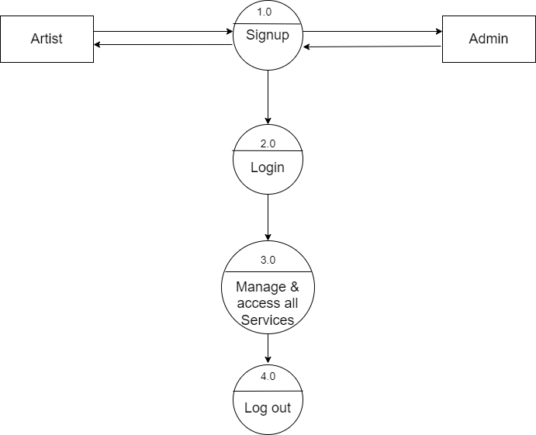

2th level DFD :

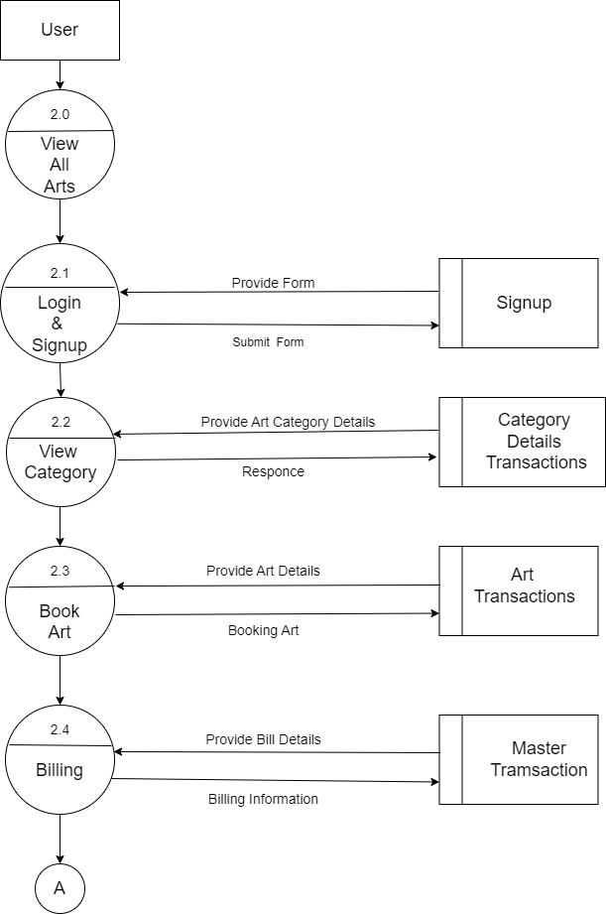

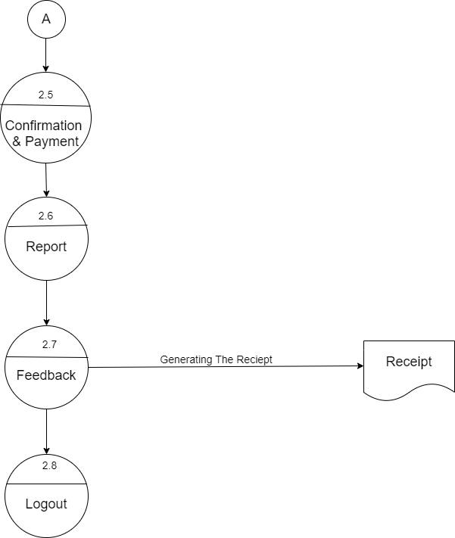

ERD

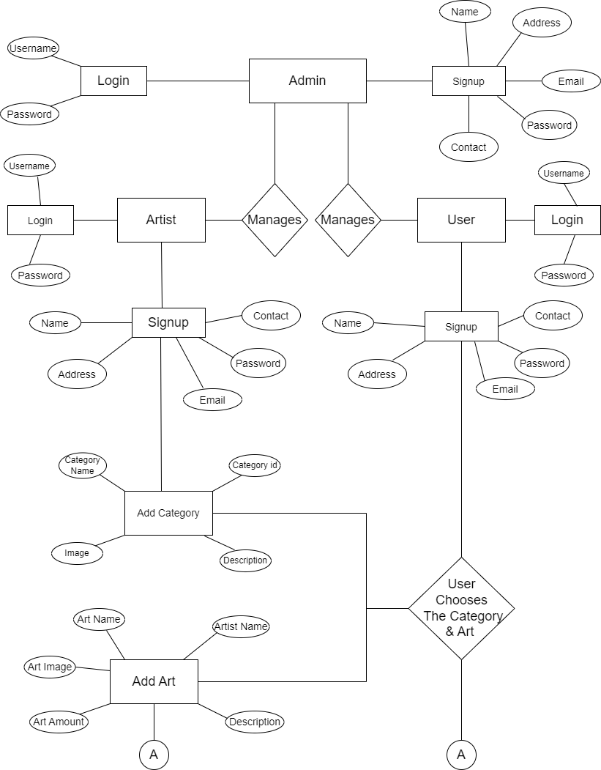

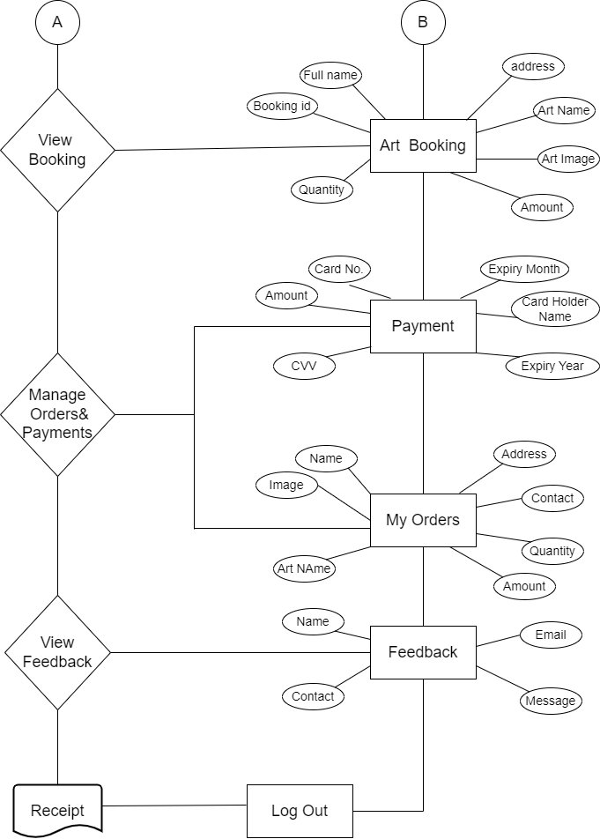

CHAPTER 4

**4. System Requirements**

* Software
* Hardware
* Front End
* Back End

Software Requirement :

• Web Browser: Any of Mozilla, Opera, chrome etc.

• Web server: NetBeans IDE 7.2

• Operating System: Windows 10 or above

• Software Development kit: Java JDK 8.0.1910.12 or above

• Database JDBC Driver: MySQL connectors

Hardware Requirement :

• Processor: Intel inside CORE 15

• RAM: 4GB or more

• Hard Disk: 20GB or More

• Keyboard: Normal

• Mouse: Compatible Mouse

Front End :

Java using JSP, CSS, HTML, Bootstrap, Glassfish Server.

Back End :

MySQL Database.

FRONT END (Java)

ABOUT JAVA

* Java is a general-purpose computer-programming language that is concurrent, class-based, object-oriented, and specifically designed to have as few implementation dependencies as possible.
* Java was originally developed by James Gosling, a Canadian, at Sun Microsystems (which has since been acquired by Oracle Corporation) and released in 1995 as a core component of Sun Microsystems' Java platform.
* Its source code is available for free inside every JDK (Java Development Kit)
* Java is a platform Independent.
* Java Is a Secure Language.
* According to Sun, 3 billion devices run Java. There are many devices where Java is currently used. Some of them are as follows:
* Desktop Applications such as acrobat reader, media player. antivirus, Web Applications, Enterprise Applications such as banking applications, Mobile, Embedded System, Smart Card, Robotics, Games etc.

WHAT'S NEW IN JAVA?

The Byte Code Concept separates java from all other language. As we know Byte Code is set of symbols created by sun Microsoft which are generated after the compilation of Program. This byte code is actually encoded source code that human cannot understand and that Byte code is converted to machine code by Java Runtime Environment. This Byte code is executed by java runtime environment which consist of Byte code loader which loads the byte code into memory and then Byte code verifier which verifies the Byte code and look for any extra symbols and code which does not resembles to the standards and throws unexpected code way and makes java byte code error free and secure. Java is fast because of JIT compiler. Just In Time compiler stores the repeated code in its cache memory and in byte code where repeated code is used, instead of loading that code again from memory JIT use it from its cache memory and safe time and space and make execution fast. Below is the graphical representation of java program. Compile Once and Run Forever "is the famous tag line of java and yes it is very true this all is possible because of Byte code as once byte code is generated you can use that byte code and can run that program in any operating system, every operating system's java runtime environment will convert that Byte Code into machine code and will give you your require output and because of this Java Byte Code is named as Portable Code or P-code. Due to its Byte code is in Bytes, java program takes very less memory on hard disk and therefore java technology is Portable also.(byte code concept) The Above features cannot be found in any other language, because of the above features java is used almost everywhere and in every application no matter its mobile application or web. Till date there is no programming language more secure than java.

What is Java Server Pages?

* Java Server Pages (JSP) is a technology for developing Webpage's that supports dynamic content.
* This helps developers insert java code in HTML pages by making use of special JSP tags, most of which start with <% and end with %>
* A Java Server Pages component is a type of Java servlet that is designed to fulfill the role of a user interface for a Java web application.
* Web developers write JSPS as text files that combine HTML or XHTML code, XML elements, and embedded JSP actions and commands.
* Using JSP, you can collect input from users through webpage

forms, present records from a database or another source, and

create Web pages dynamically.

* JSP tags can be used for a variety of purposes, such as retrieving information from a database or registering user preferences, accessing JavaBeans components, passing control between pages, and sharing information between requests, pages etc.

Why Use JSP ?

* Performance is significantly better because JSP allows embedding Dynamic Elements in HTML Pages itself instead of having separate CGI files.
* JSP are always compiled before they are processed by the server unlike CGI/Perl which requires the server to load an interpreter and the target script each time the page is requested.
* Java Server Pages are built on top of the Java Servlets API, so like Servlets, JSP also has access to all the powerful Enterprise Java APIs, including JDBC, JNDI, EJB, JAXP, etc.
* JSP pages can be used in combination with servlets that handle the business logic, the model supported by Java servlet template engines.

BACK END (MYSQL SERVER)

What is Database?

A database is a separate application that stores a collection of data. Each database has one or more distinct Application for creating, accessing managing, searching and replicating the data it holds. Other kinds of data stores can be used such as files on the file system or large hash tables in memory but data fetching and writing would not be fast and easy with those types of systems. So now a days we use relational database management systems (RDBMS) TO store and manage huge volume of data. This is called relational database because all the data is stored into different bales and relations are established using primary keys or other keys known as foreign keys.

A RELATIONAL DATABAS MANAGEMENT SYSTEM (RDMS)

* Enables you to implement a database with tables, columns and indexes.
* Guarantees the Referential Integrity between rows of various tables.
* Updates the indexes automatically.
* Interprets a MySQL query and combines information from various tables

MySQL Workbench 6.3 CE

MySQL Database:

* MySQL is a fast, easy-to-use RDBMS being used for many small and big businesses. MySQL is developed, marketed, and supported by MySQL AB, which is a Swedish company, MySQL. is becoming so popular because of many good reasons:

* MySQL is released under an open-source license. So you have nothing to pay to use it.
* MySQL is a very powerful program in its own right. It handles a large subset of the functionality of the most expensive and powerful database packages.
* MySQL uses a standard form of the well-known SQL data language.
* MySQL works on many operating systems and with many languages including PHP, PERL, C, C++, JAVA, etc.
* MySQL, works very quickly and works well even with large data sets.
* MySQL is very friendly to PHP, the most appreciated language for web development.
* MySQL supports large databases, up to 50 million rows or more in a table. The default file size limit for a table is 4GB, but you can increase this (if your operating system can handle it) to a theoretical limit of 8 million terabytes (TB).
* MySQL is customizable. The open-source GPL. License allows programmers to modify the My SQL software to fit their own specific environments.

CHAPTER 5

**5. System Design**

* Database Design
* Output Design

Database Design

**Admin Signup Table:**

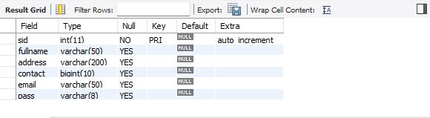

**Add Category:**

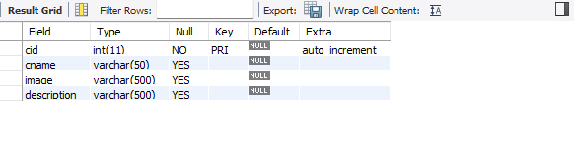

**Artist Signup:**

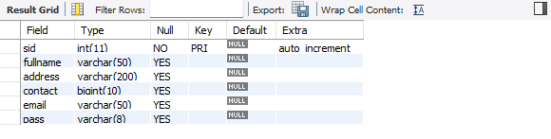

**Add Art:**

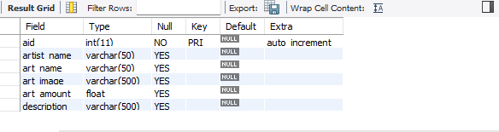

**User Signup:**

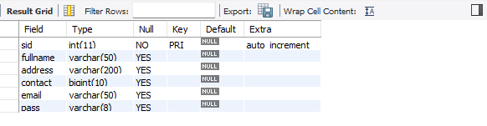

**Art Booking:**

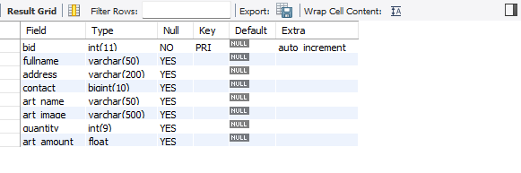

**Payment:**

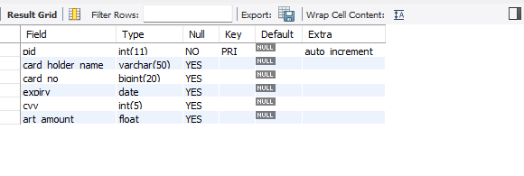

**Feedback:**

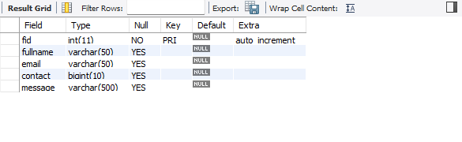

Output Designs

Home Page:

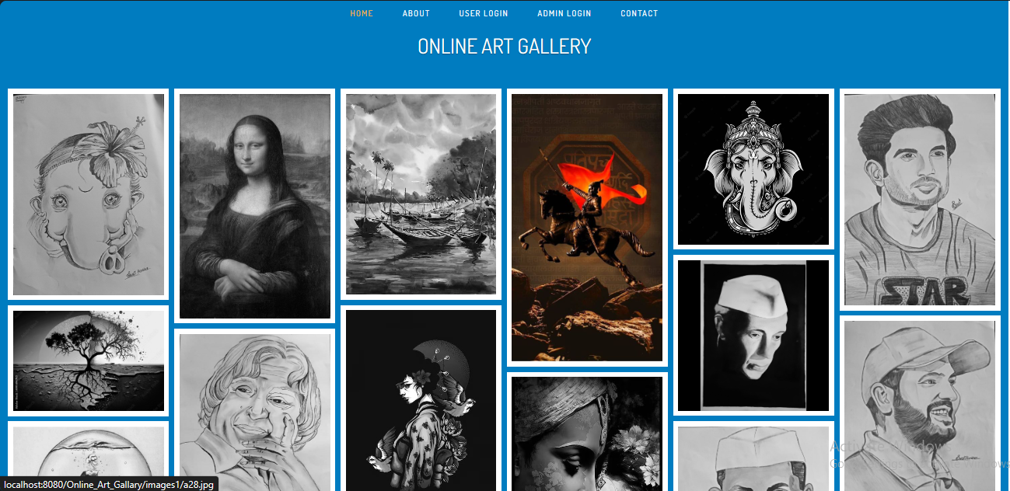

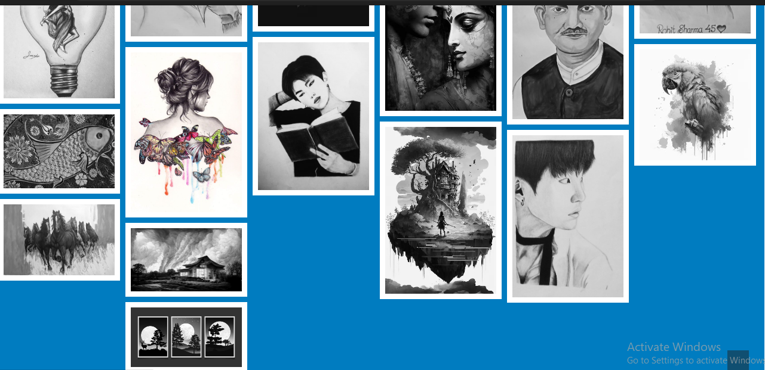

Admin **Login** :

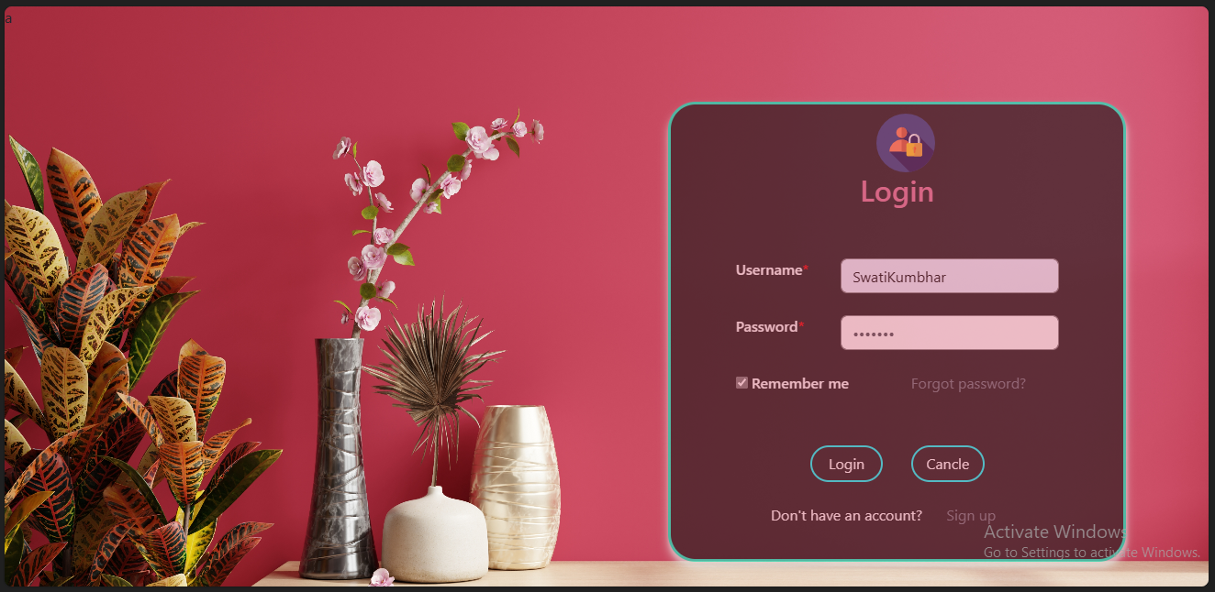

Admin Signup :

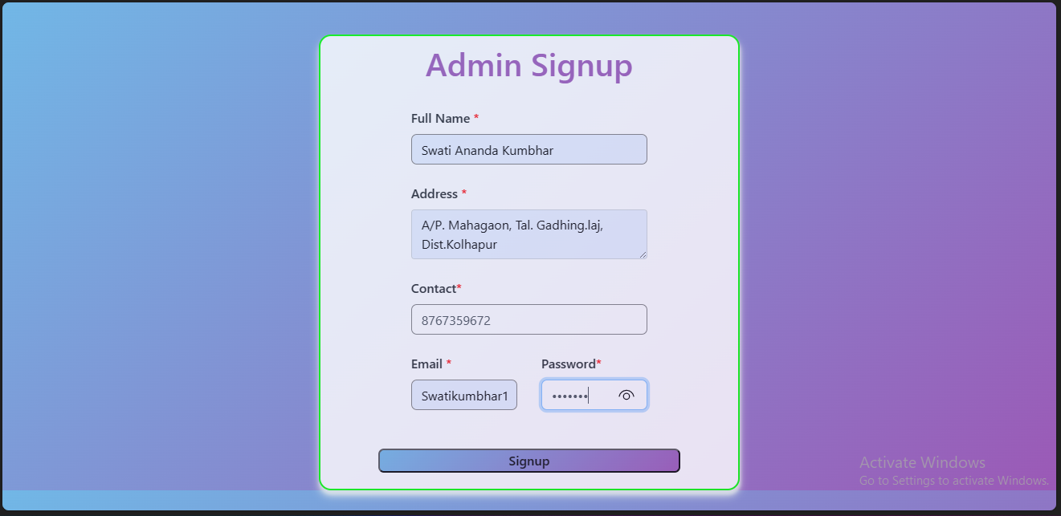

Add Category :

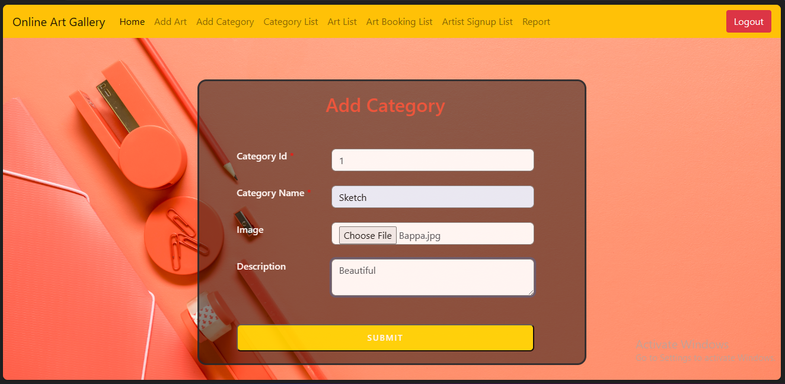

Artist Login :



Artist Signup :

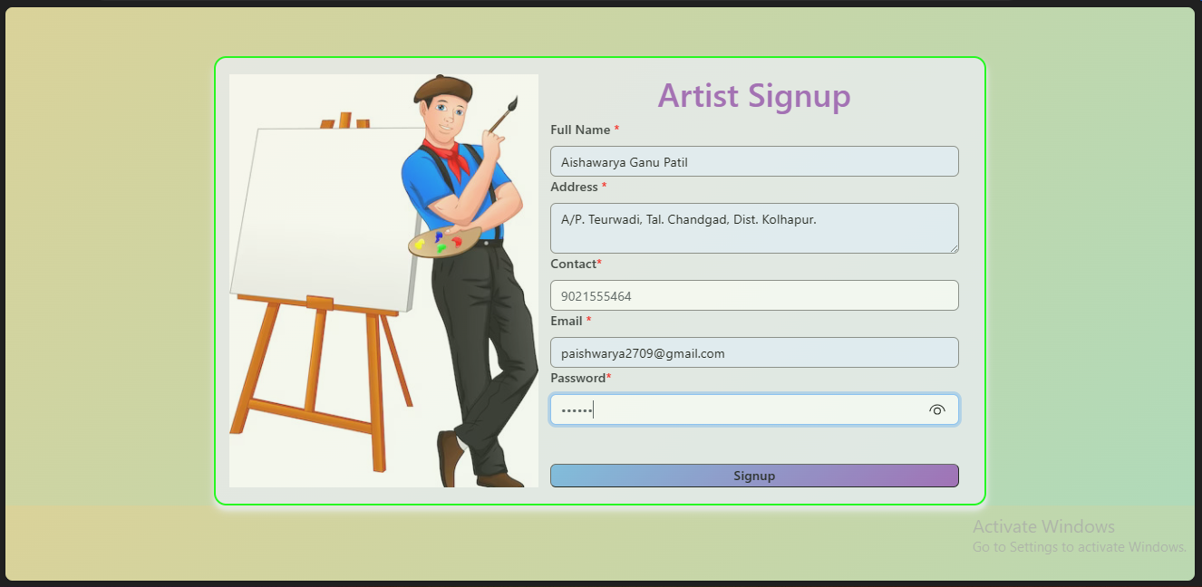

Add Art :

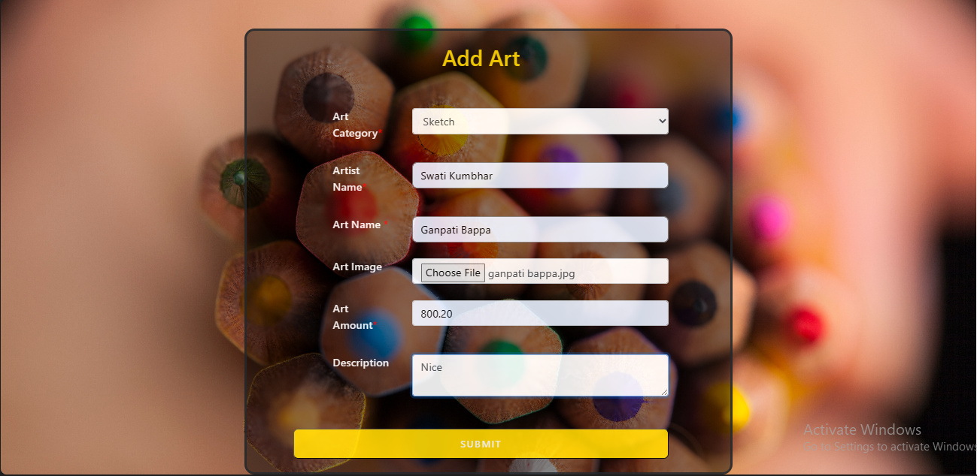

User Login :

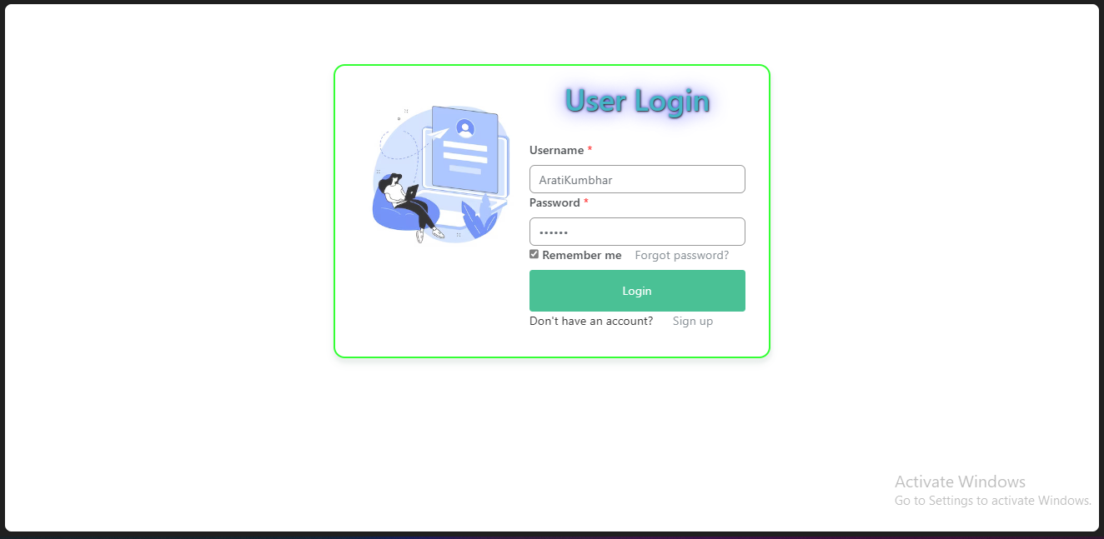

User Forgot Password :

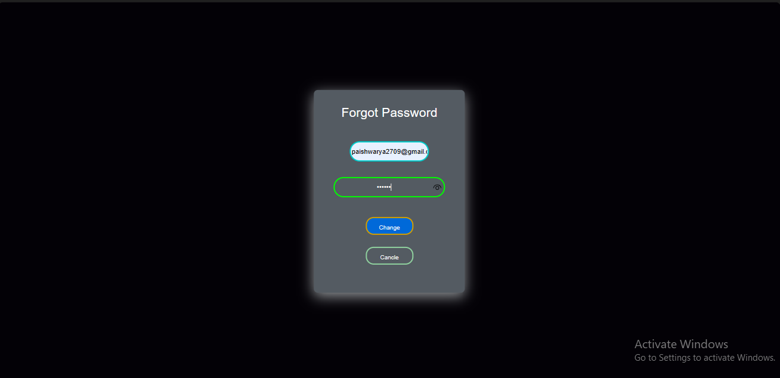

User Signup :

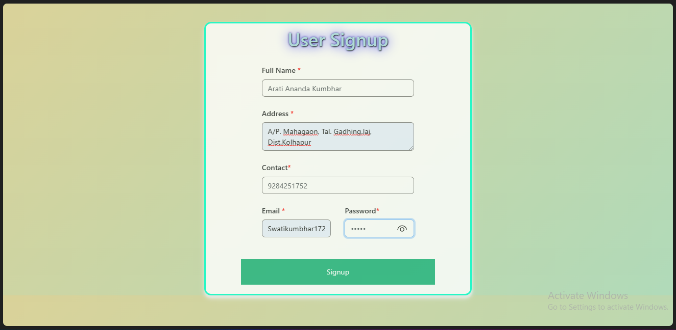

Category View :

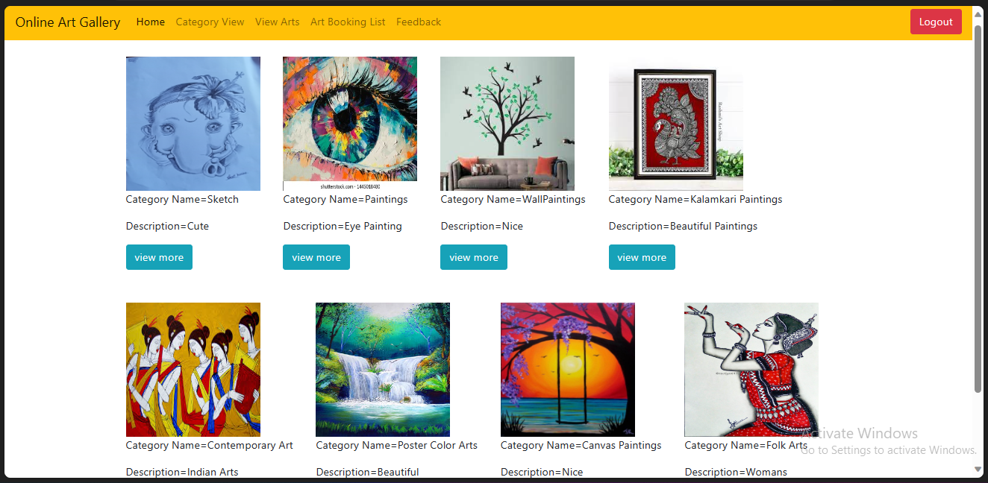

Art View :

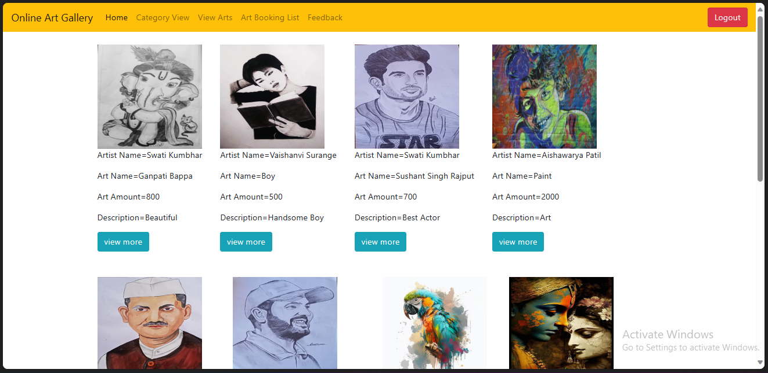

Art Booking :

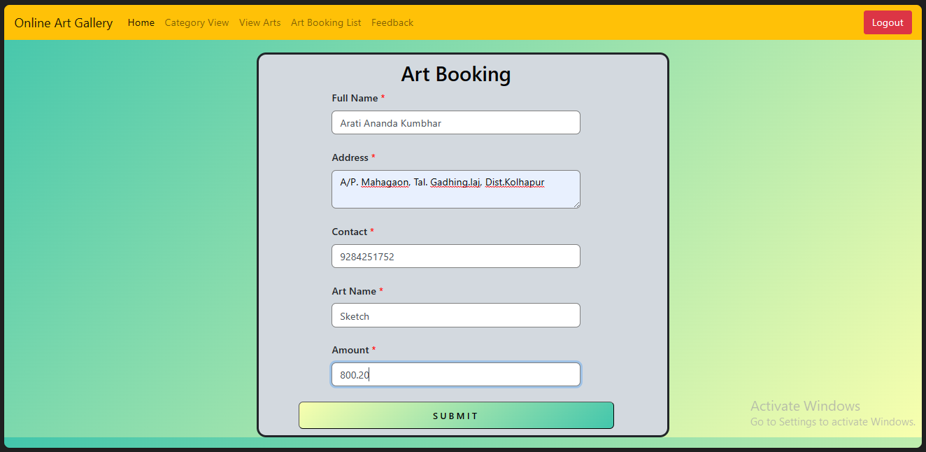

Payment :

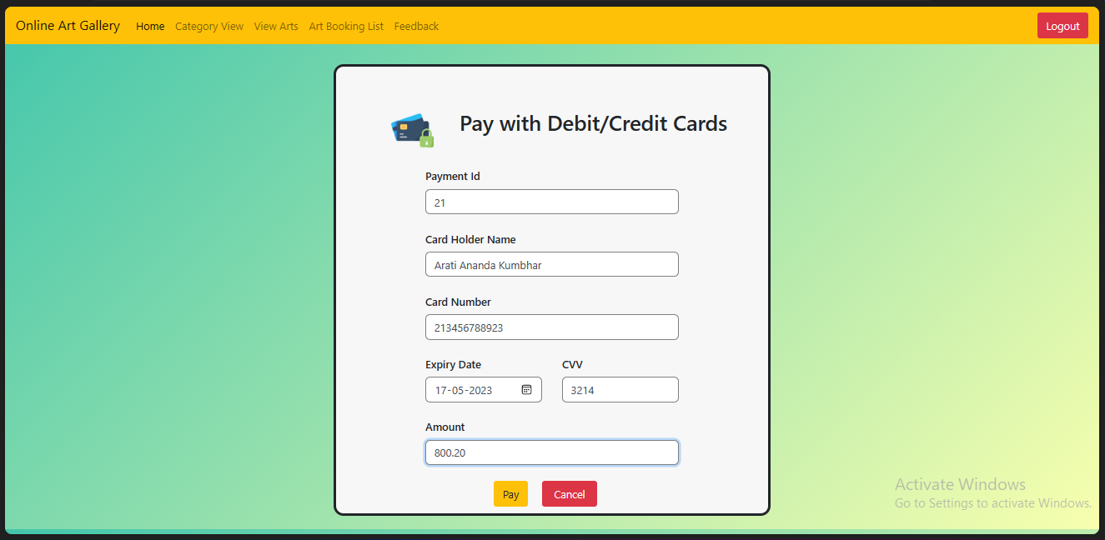

Feedback :

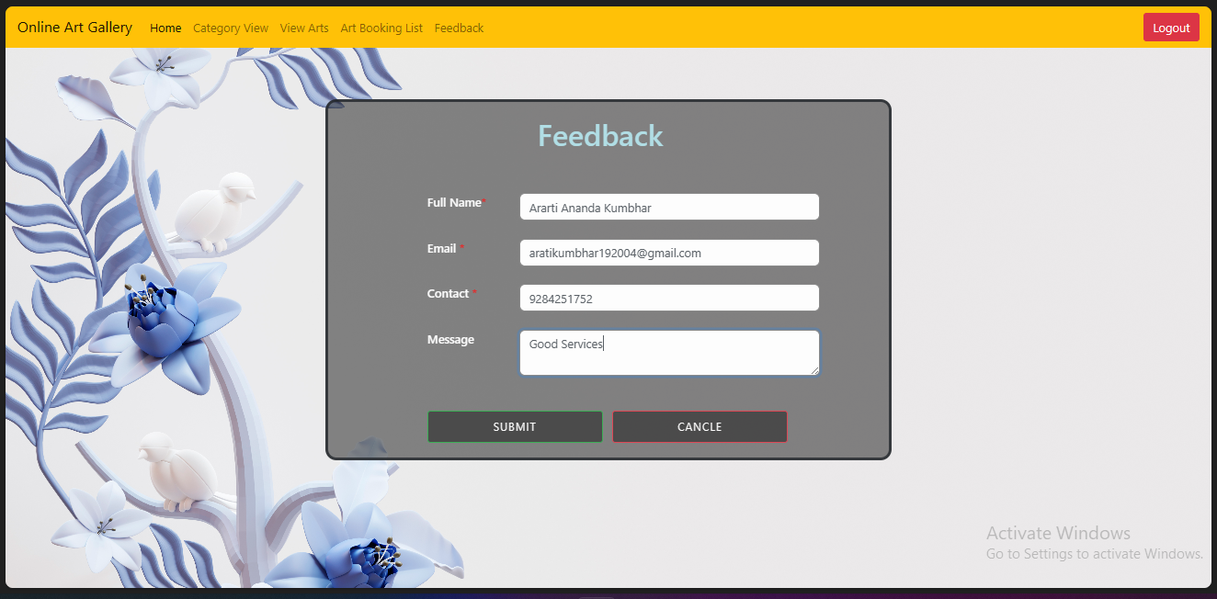

CHAPTER 6

**6. User Guideline**

* Installation process

Installation Process :

We need to installs Netbeans, MySQL and Jdk for this software development.

1. Netbeans :

**Step 1:** You need to have a setup file of the NetBeans JAVA into your setup

**Step 2:** If you didn't have the setup you can download the following link:

**Step 3:** You can download any type of setup as per your requirement from the above mention link.

**Step 4:** Right-click on the setup or you can Double-click on the setup by using the mouse.

**Step 5:** Click on the next option.

**Step 6:** Check on the "Private networks, such as my home and work network"

**Step 7:** Click on the Allow access button.

**Step 8:** Check on the "I accept" option and click on the "Next" button.

**Step 9:** Select the path where you want to install the software and press the "Next" button.

**Step 10:** Click on the "Next" button.

**Step 11:** Click on the "Install" button.

**Step 12:** Wait for the while till the time the setup is properly Installed into the Computer.

**Step 13:** After complication of the setup you can click on the "Finish" button or you can also register the Software, for Further Assistance because it is a Free Software.

**Step 14:** Now you can start the NetBeans for further use.

1. MySQL :

**Step 1:** Go to the official website of MySQL and download the community server edition software. Here, you will see the option to choose the Operating System. Such as Windows.

**Step 2:** Next, there are two options available to download the setup. Choose the version number for the MySQL community server, which you want. If you have good internet connectivity, then choose the mysql-installer-web-community. Otherwise, choose the other one.

**Step 3:** After downloading the setup, unzip it anywhere and double click the MSI installer.exe

**Step 4:** In the next wizard, choose the Setup Type. There are several types available, and you need to choose the appropriate option to install My SQL product and features. Here, we are going to select the Full option and click on the Next button.

**Step 5:** Once we click on the Next button, it may give information about some features that may fail to install on your system due to a lack of requirements. We can resolve them by clicking on the Execute button that will install all requirements automatically or can skip them. Now, click on the Next button

**Step 6:** In the next wizard, we will see a dialog box that asks for our confirmation of a few products not getting installed. Here, we have to click on the Yes button

**Step 7:** Once we click on the Execute button, it will download and install all the products. After completing the installation, click on the Next button.

**Step 8:** In the next wizard, we need to configure the MySQL Server and Router Here, I am not going to configure the Router because there is no need to use it with MySQL. We are going to show you how to configure the server only. Now, click on the Next button.

**Step 9:** As soon as you will click on the Next button, you can see the screen below Here, we have to configure the MySQL Server. Now, choose the Standalone My SQL Server Classic My SQL Replication option and click on Next. Here, you can also choose the InnoDB Cluster based on your needs.

**Step 10:** In the next screen, the system will ask you to choose the Config Type and other connectivity options. Here, we are going to select the Config Type as 'Development Machine' and Connectivity as TCP/IP, and Port Number is 3306, then click on Next.

**Step 11:** Now, select the Authentication Method and click on Next. Here, I am going to select the first option.

**Step 12:** The next screen will ask you to mention the MySQL Root Password. After filling the password details, click on the Next button.

**Step 13:** The next screen will ask you to configure the Windows Service to start the server. Keep the default setup and click on the Next button.

**Step 14:** In the next wizard, the system will ask you to apply the Server Configuration. If you agree with this configuration, click on the Execute button.

**Step 15:** Once the configuration has completed, you will get the screen below. Now, click on the Finish button to continue.

**Step 16:** In the next screen, you can see that the Product Configuration is completed. Keep the default setting and click on the Next-> Finish button to complete the MySQL package installation.

**Step 17:** In the next wizard, we can choose to configure the Router. So click on Next->Finish and then click the Next button.

**Step 18:** In the next wizard, we will see the Connect to Server option. Here, we have to mention the root password, which we had set in the previous steps.

**Step 19:** In the next wizard, select the applied configurations and click on the Execute button.

**Step 20:** After completing the above step, we will get the following screen. Here, click on the Finish button.

**Step 21:** Now, the MySQL installation is complete. Click on the Finish button.

1. JDK :

1. Start the JDK 8.0u installer by double-clicking the installer's icon or file name in the download location.

2. Follow the instructions provided by the Installation wizard.

3. After the installation is complete, delete the downloaded file to recover the disk space.

4. Select Control Panel and then System.

5. Click Advanced and then Environment Variables.

6. Add the location of the bin folder of the JDK installation to the PATH variable in System Variables.

CHAPTER 7

**7. Source Code**

a<%--

Document : Admin_Login

Created on: 12 Apr, 2023, 8:49:27 PM

Author : Admin

--%>

<%@page contentType="text/html" pageEncoding="UTF-8"%>

<!DOCTYPE html>

<html>

<head>

<meta http-equiv="Content-Type" content="text/html; charset=UTF-8">

<title>Login_page</title>

<link rel="stylesheet" type="text/css" href="bootstrap.min.css">

<style>

body

{

background-image: url(images/Admin_login_image.jpg);

background-repeat: no-repeat;

background-size: cover;

}

.jumbotron

{

margin: auto auto auto auto;

margin-top: 80px;

border: 3.6px solid #00FFCC;

padding-top: 10px;

padding-bottom: 20px;

box-shadow: 0px 7px 10px 0px #E7ECEA,1px 5px 4px 0px #E7ECEA;

border-radius: 30px;

background: #141414;

margin-right:90px;

width: 38%;

opacity: 0.6;

}

.jumbotron:hover

{

transition: 0.9s ease-in-out;

border:2.6px solid #00FF00;

}

.btn

{

border-radius: 20px;

color: white;

border: 2px solid rgb(0, 255, 255);

background: none;

height: 40px;

width: 40%;

}

.btn:hover

{

transition: 0.5s ease;

border:2px solid rgb(128, 0, 128);

}

label

{

color: white;

font-weight: 500;

}

.jumbotron p

{

color: white;

}

.jumbotron p:hover

{

color:yellow;

}

input[type=text],input[type=password]

{

border-color: grey;

border-radius: 7px;

}

span

{

color: red;

}

</style>

<script src="validation.js"></script>

</head>

<body>

<form action="Admin_Login" method="post">

<div class="jumbotron">

<div class="row">

<div class="col-sm-5"></div>

<div class="col-sm-2">

<img src="images/loginicon1.png" >

</div>

<div class="col-sm-5"></div>

</div>

<h2 style ="color:palevioletred; text-align:center">Login</h2>

<br><br>

<div class="row">

<div class="col-sm-1"></div>

<div class="col-sm-3">

<label>Username<span>*</span></label>

</div>

<div class="col-sm-7">

<input type="text" name="txt_name" onkeypress="javascript:return isString(event)" placeholder="Enter Username" class="form-control" required=" ">

</div>

<div class="col-sm-1"></div>

</div>

<br>

<div class="row">

<div class="col-sm-1"></div>

<div class="col-sm-3">

<label>Password<span>*</span></label>

</div>

<div class="col-sm-7">

<input type="password" name="txt_pass" placeholder="****" class="form-control" required=" ">

</div>

<div class="col-sm-1"></div>

</div>

<br>

<div class="row">

<div class="col-sm-1"></div>

<div class="col-sm-5">

<input type="checkbox">

<label>Remember me</label>

</div>

<div class="col-sm-5">

<a class="text-muted" href="Admin_forgot_pass.jsp">Forgot password?</a>

</div>

</div>

<br><br>

<center>

<div class="row">

<div class="col-sm-3"></div>

<div class="col-sm-6">

<input type="submit" name="btn" value="Login" class="btn btn-primary btn-floating" >&nbsp;&nbsp;&nbsp;&nbsp;&nbsp;&nbsp;

<input type="submit" name="btn" value="Cancle" class="btn btn-danger btn-floating" >

</div>

<div class="col-sm-3"></div>

</div>

</center>

<br>

<div class="row">

<div class="col-sm-2"></div>

<div class="col-sm-9">

<p>Don't have an account?

&nbsp;&nbsp;&nbsp;&nbsp; <a class="text-muted" href="Admin_Signup.jsp">Sign up</a></p>

</div>

</div>

</div>

</form>

</body>

</html>

CHAPTER 8

**8. Outputs**

* Input screens and Reports (with valid Data)

Reports

**Category Details:**

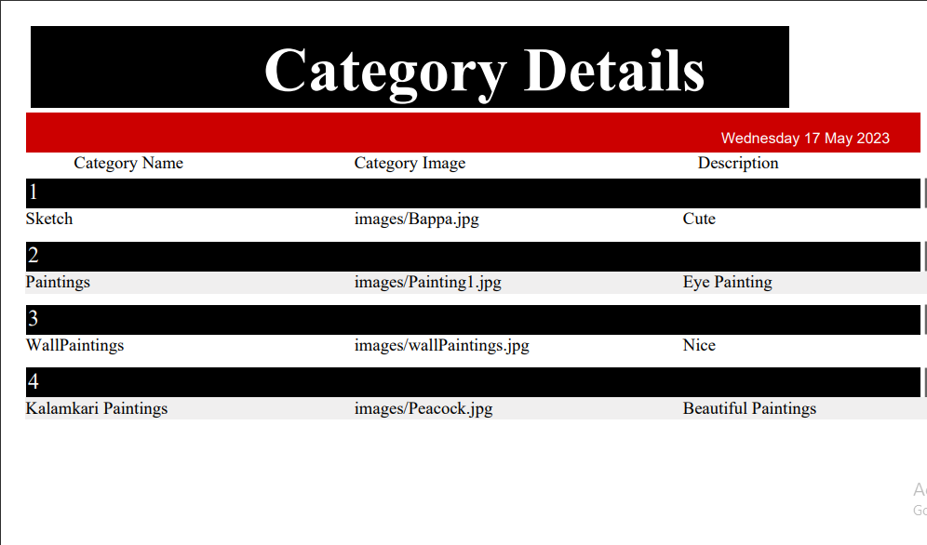

**Art Details:**

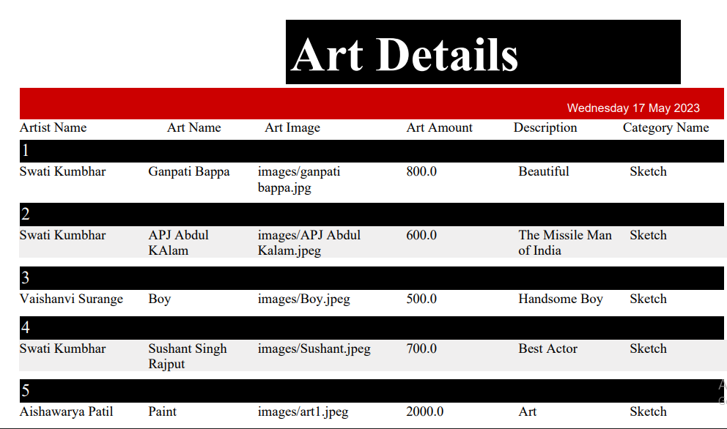

**Booking Details:**

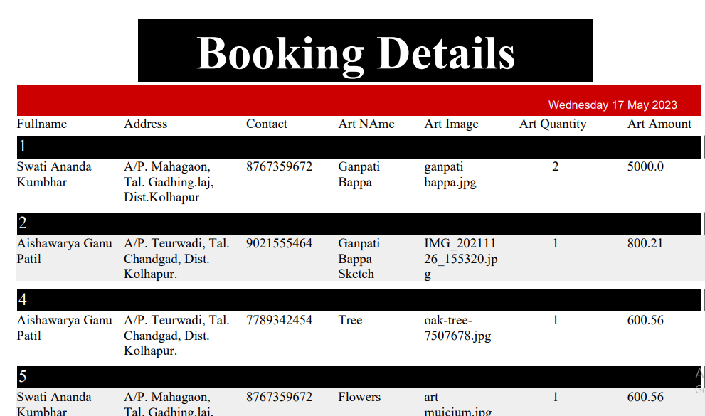

CHAPTER 9

**9. Testing**

Testing

Testing Procedure and Implementation

Levels of testing:

* Black Box testing:
* It is also called as Behavioural / Specification- Based/Input-Output Testing.
* Black Box Testing is a software testing method in which testers evaluate the functionality of the software under test without looking at the internal code structure. This can be applied to every level of software testing such as Unit, Integration, System and Acceptance Testing.
* White Box testing:
* White - box testing: Testing based on an analysis of the internal structure of the component or system. White-box testing is a method of testing the application at the level of the source code. These test cases are derived through the use of the design techniques mentioned above: control flow testing, data flow testing, branch testing, path testing, statement coverage and decision coverage as well as modified condition/decision coverage. White-box testing is the use of these techniques as guidelines to create an error-free environment by examining any fragile code

CHAPTER 10

**10. Conclusion and Suggestions**

* Conclusion and suggestions
* Future enhancement
* Bibliography

Conclusion

ONLINE ART GALLERY is a Website and it is very helpful for the art lovers and other who wants to know the addresses where this kind of arts will we sold.

This website helps the end-users to search their arts and paintings and they can place order for the selected pieces.

Art Gallery brings you an opportunity to view online art exhibitions at our Online Art Gallery we bring you details of all art exhibitions held in the past and the forthcoming show. The Online Art Gallery is updated daily, so the user can view and buy the latest collection of contemporary art online from anywhere in the world. You can view and buy the latest Indian contemporary art collection available at their exhibitions and also at their online gallery.

The online art gallery project will provide a valuable platform to artists to showcase there talent and enable art enthusiasts to discover and purchase unique artworks.

The platform will continue to involve and improve its features to provide a truly immersive & seamless experience for the users.

Future Enhancement

In any system there is always chance for its enhancement and extension. This system can also be enhanced with the change facilities. Also with the progress of the Fashion Design system can also be enhance in future. More facilities can be added to the system for its growth. There is always scope for enhancements in any system, especially in the ever- changing world of computers. The Fashion design System can also be modified according to the feature requirements the advancement of the technology.

More Functionality can be added depending upon the user requirements and Specifications. Currently application running on phase-1 which is awareness phase. In future according to requirement I update this system to phase-2.I trying to increase software performance by using maximum use of core. The project can be expanding as per the need of the company and if there will any more requirements that can be satisfy.

* The product can enter any user requirements.
* The application is currently stand alone and can be extended for the web.
* The product creation part is to done in a more elaborate manner.

Bibliography



Websites:

* [www.google.com](http://www.google.com)
* [www.github.com](http://www.github.com)
* www.ProjectGreek.com

Books:

1. Herbert Schildt, Java2: The Complete Reference, Tata McGrawHill

2. Object Oriented Programming with JAVA Essentilas and Applications, Mc Graw Hill.

3. Core and Advanced Java, Black Book- dreamtech.

4. Programming with JAVA-E Balagurusamy.